Belmont Community Day Care Center
2340 Cambreleng Avenue
Bronx N.Y. 10458
718-584-1576

2021-2022 Calendar

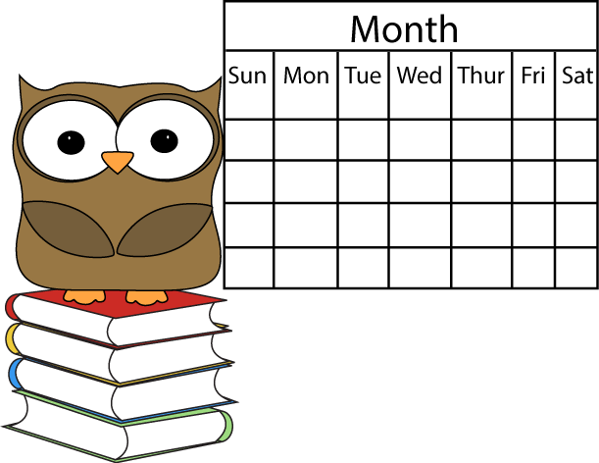

Key: Extended Day – Families that have completed eligibility Paperwork and were approved for an extension to their school day slot.
Holiday – Building is closed / All programs Closed
Remote Learning Day – No in person services / Sign on to Belmont’s YouTube channel.

September
“International Literacy Month”
Sun | Monday | Tue | Wed | Thu | Fr | Sat
 |  |  | 1  Ex. Day opened | 2  Ex. Day opened | 3  Ex. Day opened | 4
5 | 6  Labor Day  Building Closed | 7  Staff  Development  Ex day opened | 8  Staff  Development  Ex day  opened | 9  Ex. Day opened | 10  Ex. Day opened | 11
12  National Grand-parents Day ! | 13  First Day of School  Meet and Greet with Families | 14 | 15  Mexico’s  Independence  Yom Kippur  Ex. Day Opened | 16 | 17  Dad  Bring  your  child to  School  Day! | 18
19 | 20 | 21 | 22  Autumn  Begins | 23 | 24  Farmers  Market Tours  Begin! | 25
26 | 27  Parent Meetings begin. | 28 | 29 | 30
Sun | Mon | Tues | Wed | Thu | Fri | Sat
 |  |  |  |  | 1  PAC | 2  Open House  10-1
3 | 4  Child Abuse  Meeting  Parents | 5 | 6 | 7 | 8 | 9
10 | 11  Columbus Day  Building Closed | 12 | 13 | 14  Virtual Movie Night  TBA | 15 | 16
17 | 18  Apple Cider  Press | 19  Apple Cider  Press | 20  Apple Cider  Press | 21  Apple Cider  Press | 22  Apple  Cider Press | 23
24  __  31  Happy  Halloween | 25  Penny Harvest  Begins | 26 | 27  Pumpkin Picking | 28  Pumpkin  Picking  Read  For the  Record  By. Kat Zhang  Amy Wu and the Patchwork Dragon | 29  Halloween  Parade | 30

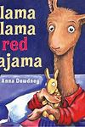
October
“School Safety Month”
Book of The Month
November
“Good Nutrition Month”

Sun | Mon | Tue | Wed | Thu | Fri | Sat
 | 1  Food Drive  Begins  Turkey  Raffle | 2  PD Day  Remote Learning Day  All  Programs closed | 3 | 4 | 5 | 6
7  Daylight Saving Time | 8 | 9 | 10 | 11  Veterans Day  Building Closed | 12 | 13
14 | 15  Book Fair | 16  Book Fair | 17  Book Fair | 18  Book Fair | 19  Fall Checklist | 20
21 | 22 | 23 | 24  Turkey  Feast | 25  Thanksgiving  Building  Closed | 26  Holiday  Building Closed | 27
28 Hanukkah  Begins at Sundown | 29  Toy Drive  Begins | 30  Virtual Safety  Training  Maria Cruz
Book of the Month
December
“Write to a Friend Month”
Sun | Mon | Tue | Wed | Thu | Fri | Sat
 |  |  | 1  Tree Lighting  Ceremony  6:30 | 2  Muscle Man Mike Show | 3 | 4
5 | 6 | 7  Pearl  Harbor Day | 8 | 9  Daddy and Me Ornament Making 6:30 | 10 | 11
12 | 13 | 14 | 15 | 16 | 17  Santa  Comes to  Belmont | 18
19 | 20 | 21  First Day of  Winter Solstice | 22 | 23 | 24  Christmas Eve  Building Closed | 25
26  Kwanzaa  Begins | 27  Winter Recess  Building Closed | 28  Winter Recess  Building Closed | 29  Winter Recess  Building Closed | 30  Winter Recess  Building Closed | 31  Winter Recess  Building Closed

Book of The Month
January
“National Book Month”
Sun | Mon | Tue | Wed | Thu | Fri | Sat
 | Baby Chick Hatching |  |  |  |  | 1
2 | 3  Return to  School  All | 4 | 5 | 6  Epiphany | 7 | 8
9 | 10 | 11 | 12 | 13 | 14  Teddy Bear  Curriculum | 15
16 | 17  Martin Luther King Jr.  Building  Closed | 18 | 19 | 20 | 21 | 22
23 | 24 | 25 | 26 | 27  Flat Stanley  Gallery  6:30 | 28 | 29
30 | 31  Lunar New Year  Celebration
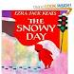Book of The Month
February
“American Heart Month”

Sun | Mon | Tues | Wed | Thu | Fri | Sat
 |  | 1  Lunar New Year  Remote Learning  PD Day  All Programs Closed | 2  Ground-Hog’s Day  Hair Hog  Parade | 3 | 4  Pre-K  Pajama Day | 5
6 | 7 | 8 | 9 | 10  Valentines  Day Dance | 11 | 12
13 | 14  Happy Valentine’s Day! | 15 | 16 | 17 | 18  Winter  Checklist | 19
20 | 21  Presidents Day  Winter Recess  Building Closed | 22  Ex. Day Program  Opened | 23  Ex. Day Program  Opened | 24  Ex. Day Program  Opened | 25  Ex. Day Program  Opened | 26
27 | 28

Book of The Month
March
“Music in Our Schools Month”

Sun | Mon | Tue | Wed | Thu | Fri | Sat
 |  | 1  Fat Tuesday | 2  Ash Wednesday  Dr. Seuss  Birthday | 3  Muscle Man Mike Show | 4  Crazy  Hat Day  Celebration | 5
6 | 7 | 8 | 9 | 10 | 11 | 12
13  Day Light  Savings  Time | 14  Happy St. Patrick’s Day | 15 | 16 | 17  Bingo Night  6:30 | 18 | 19
20  Spring  Equinox | 21 | 22 | 23 | 24 | 25 | 26
27 | 28 | 29 | 30

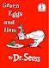Book of The Month
April
“Month of the Young Child”

Sun | Mon | Tues | Wed | Thu | Fri | Sat
 |  |  |  |  | 1  April  Fool’s Day | 2
3 | 4 | 5 | 6 | 7 | 8 | 9
10  Palm Sunday | 11 | 12  Egg  Hunt | 13  Egg  Hunt | 14  Passover Begins | 15  Good  Friday  Remote Learning Day  PD Day | 16
17 | 18  Ex. Day Program  Opened | 19  Ex. Day Program  Opened | 20  Ex. Day Program  Opened | 21  Ex. Day Program  Opened | 22  Ex. Day Program  Opened  Earth Day | 23
24 | 25 | 26 | 27 | 28 | 29 | 30
Book of The Month
May
“National Share -a-Story Month”
Sun | Mon | Tue | Wed | Thu | Fri | Sat
1 | 2  Teacher Appreciation Week  Eid al-Fitr  Ex. Day  Program | 3  Teacher Appreciation Week | 4  Teacher Appreciation Week | 5  Teacher Appreciation Week  Cinco de Mayo | 6  Teacher Appreciation Week | 7  Month of Young Child
8  Mother’s  Day | 9 | 10 | 11 | 12 | 13 | 14
15 | 16 | 17 | 18 | 19 | 20 | 21
22 | 23  Book Fair | 24  Book Fair | 25  BookFair | 26  Book Fair | 27  Book Fair | 28
29 | 30 | 31  Picture Day | 26  Picture Day | 27 | 28  Spring Checklist | 29
30 | 31 Memorial  Day  Building Closed

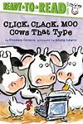 Book of The Month

June
“Great Outdoors Month”

Sun | Mon | Tue | Wed | Thu | Fri | Sat
 |  |  | 1 | 2 | 3 | 4
5 | 6 | 7 | 8 | 9 | 10  Moving  Up  Ceremony | 11
12 | 13  Flag Day | 14 | 15  Class  BBQ | 16  Class  BBQ | 17  Class  BBQ  Room 1  Yankee / Met Day! | 18
19  Father’s Day  Summer  Solstice  Juneteenth | 20  Ex Program Open | 21  Class  BBQ | 22  Class  BBQ | 23  Class  BBQ | 24  Class  BBQ | 25
26 | 27  11:30  Dismissal | 28  Last Day of School!  11:30  Dismissal | 29  Ex Program Open | 30  Ex Program Open

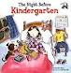Book of The Month

July

Sun | Mon | Tue | Wed | Thu | Fri | Sat
 |  |  |  |  | 1  Ex Program Open | 2
3 | 4  Holiday  4th of July | 5  Ex Program Open | 6  Ex Program Open | 7  Ex Program Open | 8  Ex Program Open | 9
10 | 11  Ex Program Open | 12  Ex Program Open | 13  Ex Program Open | 14  Ex Program Open | 15  Ex Program Open | 16
17 | 18  Program closed | 19  Program closed | 20  Program closed | 21  Program closed | 22  Program closed | 23
24 | 25  Program closed | 26  Program Closed | 27  Program closed | 28  Program closed | 29  Program closed | 30
31

August

Sun | Mon | Tue | Wed | Thu | Fri | Sat
 | 1  Program closed | 2  Program closed | 3  Program closed | 4  Program closed | 5  Program closed | 6
7 | 8  Program closed | 9  Program closed | 10  Program closed | 11  Program closed | 12  Program closed | 13
14 | 15  Program closed | 16  Program closed  Clerical | 17  Program closed  Clerical | 18  Program closed  Clerical | 19  Program closed  Clerical | 20
21 | 22  Ex Program Open | 23  Ex Program Open | 24  Ex Program Open | 25  Ex Program Open | 26  Ex Program Open | 27
28 | 29  Ex Program Open | 30  Ex Program Open | 31  Ex Program Open

