Belmont Community Day
Care Center
2340 Cambreleng Avenue
Bronx N.Y. 10458

Parent Hand Book



Since 1971
Our Children are our #1 Priority

Update: September 2025

Just Playing 
When I am building in the block room, please don't say I'm "just playing". For you see, I'm learning as I play, about balance and shapes. Who knows, I may be an architect someday.
When I'm getting all dressed up, setting the table, caring for the babies, don't get the idea I'm "just playing". For, you see, I'm learning as I play; I may be a mother or a father someday.
When you see me up to my elbows in paint or standing at an easel, or molding and shaping clay, please don't let me hear you say, "He is just playing". For, you see, I'm learning as I play. I'm expressing myself and being creative. I may be an artist or an inventor someday.
When you see me sitting in a chair "reading" to an imaginary audience, please don't laugh and think I'm "just playing". For, you see, I'm learning as I play. I may be a teacher someday.
When you see me combing the bushes for bugs, or packing my pockets with choice things I find, don't pass it off as "just play". For you see, I'm learning as I play. I may be a scientist someday.
When you see me engrossed in a puzzle or some "plaything" at my school, please don't feel the time is wasted in "play". For, you see, I'm learning as I play. I'm learning to solve problems and concentrate. I may be in business someday.
When you see me cooking or tasting foods, please don't think that because I enjoy it, it is "just play". I'm learning to follow direction and see differences. I may be a cook someday.
When you see me learning to skip, hop, run and move my body, please don't say I'm "just playing". For, you see, I'm learning as I play. I'm learning how my body works. I may be a doctor, nurse or athlete someday.
When you ask me what I've done at school today, and I say, "I just played", please don't misunderstand me. For you see, I'm learning as I play. I'm learning to enjoy and be successful in my work. I'm preparing for tomorrow. Today, I am a child and my work is play.
~Anita Wadley
http://justplayingpoem.com/

Table of context

Introduction, History, Hours of Operation, Days in Service, Administrative Team
Eligibility, Intake Process, Recertification, Enrollment Process
Holidays, Vision Statement, Mission Statement, Primary Goals, Philosophy,
Discipline Code of Conduct
Classroom Management Guide/ Educators Mission Statement
Curriculum, Units of Study, Common Core Pre-Kindergarten Foundation/ Flow of The Day
Children’s Assessment, Teacher Parent Meet and Greet, Open Door Policy, ESI-R, PKBS, Portfolio
EDUCA, Learning Stories, Daily Observations
Special Needs, Services, Social Services and Counseling,
Family Mental Health and Services Plan, DOE Mental Health and Educational consultants, Dual Language Learners
Family Involvement, Fund Raising,
Parents get Involved, Parent trainings and Workshops, Family Room, Parent Survey
Cool Culture, PAC, Book of the Month, Special Events
Medicals, Asthma Action
Vision and Hearing Services, Epinephrine Auto injectors, Mat Certification, Escort Policy, Transition and Continuity
Transition to Kindergarten, Photograph Release, Instructional Staff Development Days
Payment and fees, Materials, Mandated Reporters
Attendance, Absences, Communication Devices
Instructional Meals Nutrition at Belmont, Suggested Parent Activities, Informative Websites, Event Request Form, Birthday Parties
Breast Feeding Policy, Trauma Smart

Enhancements of the Program,
Library, Literacy Program CAT, Sensory Area, Studio in a school Reading Buddies, Indoor /outdoor Recreation, Block Room, Educational Workshops, Consultants and Trips, Trip etiquette Eat Well Play Hard, Future Chef, Cornell University, Dads take your child to School, Month of the young Child, Bilingual Birdies, Parent Helper Agreement
Animals in the Classroom,
Program Assessment, ECERS, NAEYC, CLASS

“There is nothing more rewarding in life than to positively touch the life of a child.”
Eugene Lorelli
Chairman
June 1971

Belmont Community Day Care Center
2340 Cambreleng Avenue
Bronx, N.Y. 10458
718-584-1576
718-584-4443
bcdaycare@verizon.net
Dear Parents and Guardians,
The Belmont Administration and staff would like to welcome your family into our community-based family. It is with great pride that we supply your child with a safe, educational environment. Our overall goal is to help your child develop, on an individual basis, by preparing them for further educational opportunities. If you have any questions or concerns, please come to the front reception desk and we will assist anyway we can.
History:
The Belmont Community Day Care Center Inc. has been in existence and servicing the Belmont Community and surrounding areas since 1971. The center is located in Community District Board #6, one of the most racially and ethnically diverse districts in the Bronx. The Belmont is encompassed by a community rich in culture, affording many learning opportunities for young minds. It is home to Fordham University, The Wildlife Conservation Society (Bronx Zoo), The New York Botanical Gardens, The Enrico Fermi Cultural Center and Library, St. Barnabas Hospital and Arthur Avenue/ East 187th street, also known as the “Little Italy” of the Bronx. These cultural institutions willingly open their doors to foster learning experiences for young children and their families. Throughout the years the Belmont has developed a positive relationship with these organizations enriching our program with many resources for our children and families.
Hours of Operation:
Building Hours: 7:30 -5:30 Extended Day
9:00- 3:20 School Day Pre-K – 4
8:00- 2:30 School Day Pre-K – 3

Days in Services:
School Day 180 Days
Extended Day 225 Days
Administrative Team:
Danielle Adornetto Educational Director
Jennifer Colello Assistant Educational Director
Johannah Adornetto Financial Administrator
Nicolas Doran Head Cook
Marcela Bravo Housekeeping Manager
Eligibility Officer

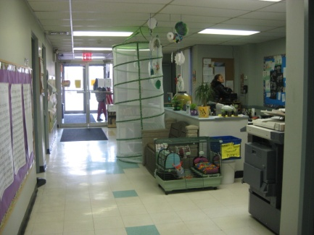
Eligibility:
Eligibility is done on sight at the Belmont Community Day Care Center. Eligibility at the center consist of Extended day budgeted slots, vouchers, and School Day Application. All families must apply online at Myschools.com. Please call for additional information.
Intake Process:
This is an opportunity for the parents, child and director to meet. Policy and procedures are discussed during this meeting. A questionnaire is filled out about the individual child. All parents must come in for the intake process before the child can begin in the center. Children need to be present during the intake process.
Recertification:
All parents are responsible for their recertification. Parents will receive recertification packages in the mail. Please check with our family coordinator for assistance with the recertification process. Parents are responsible for filling out the appropriate paper work and mailing the package in a timely fashion.
Enrollment Process
Step I: Eligibility Process

Eligibility Process:
Eligibility is done on site at the Belmont Community Day Care Center. Please call to make an appointment. Eligibility at the center consist of Extended day budgeted slots and HRA vouchers.
- Pay Stubs (12 if paid every week, 6 if paid every 2 weeks, and 1069 Form if paid cash)
- Birth certificates of all the children in the household under 18
- Provider Forms
- Social Security card
- 2 proofs of address
- Immunizations
- Food Stamp number (If Applicable)
Step II: Documents submitted before the first day of school
- Childs Medical – Inclusive of Vision, Hearing, Lead, influenza vaccination, Up to Date Shots, allergy and asthma information.
- Dental Form
Intake Meeting:
Policy and procedures are discussed during this meeting. A questionnaire is filled out about the individual child. All parents must come in for the intake process before the child can begin in the center. Children need to be present during the intake process.
- Notification of Child Abuse Sheet
- Reservation Letter
- Food Allergies
- Escort Policies Form
- Appropriate Materials
- Payments (Fee policy)
- Parent Hand Book/ Parent Agreement
- Regulations Regarding Food and Drink
- Blue Card
- Neighborhood Walks Permission Form
- Child Questionnaire (Child MUST Be Present)
- CACFP
- Photograph Release Form
- Immunization Record
- Yellow Medical History Form
- Asthma Survey/ Asthma Action Plan
Pre-K Documents
- Application for Community Based Organization
- Parent /Guardian Ethnic & Race Identification
- Residency Questionnaire
- Pre-Kindergarten Language Survey
Student’s information is implemented into the Child Plus Data base

Holidays:
The following days all programs at Belmont Day Care are Closed.
Martin Luther King Jr. Day Labor Day New Year’s Day
President’s Day Thanksgiving Day New Years Eve
Memorial Day Friday after Thanksgiving Columbus Day
Independence Day Christmas Week Veterans Day

Vision Statement

To create a program that develops the whole child.

Mission Statement of Belmont Community Day Care Center Inc.:

The Board of Directors, Administration, Staff, Children, parents and school Community of Belmont Day Care Center are committed to:

- Educate children intellectually, physically, emotionally and socially by recognizing individual differences while encouraging self-esteem and respect for others.
- Create a setting in which children will find warmth, comfort, and gentleness as well as an abundance of opportunities for movement, exploration, hands on experiences, sensory perception, and self-discovery.
- Develop an educational partnership between the families and the community that we service, with the mutual goal of creating lifelong learners.
- Create an environment and Curriculum designed to nurture and facilitate growth during each stage of child development.

Primary Goals of the Belmont Community Day Care Center:

1. To help every child achieve independence, self-discipline and social competence.
2. To promote and foster self-knowledge, enthusiasm for learning, positive attitudes, intellectual growth, and an organized approach to problem solving.
3. To help each child develop socially, physically and cognitively to the best of their abilities.
4. To assist parents in understanding the developmental stages of their child, enabling them to contribute most effectively to their child’s growth and enrichment.
5. To ensure that every child will be registered for a kindergarten program.

Philosophy
The Belmont Community Day Care Center strives to create and facilitate excellence in the life and experience of young children and the families we service. The Belmont believes that it takes a village to raise a child and we hold parents and family in the highest regards. Daily communication is encouraged between staff and parents. Family members and community partnerships help the Belmont to establish a cultural, safe, healthy, educational environment for all the children we work with.

- We believe that all children are individuals who learn in their own way at their own pace
- Play is the most important process through which young children learn
- Children learn through educational experiences that are developmentally appropriate
- Parents are a vital part of the learning process
- Families are invited to participate in center and classroom activities and community functions
- An educated and dedicated staff is critical to the development and maintenance of a quality early childhood program.
- The continuation of education is important to keep all our staff current and up to date on modern theories and ideas.

Discipline Code of Conduct
The mission of the Belmont Community Day Care Center’s Disciplinary Guidelines is to ensure the integrated and consistent approach to promote the physical, intellectual, and emotional well-being of the children by facilitating a coordinated team approach with the teachers and parents of our programs.
- The staff is expected to maintain order when a child’s behavior might be an endangerment to another individual or group, appropriate supervision and /or redirection of the child’s activity should take place.
- Only staff members that are trained may administer any disciplinary action. The action shall be prompt and be related to the child’s actions so that he/she is aware of the relationship between his/her actions and the consequences of those actions. Explanation is part of this process to assure each child.
- The staff should administer disciplinary action in such a way to help the child develop self-control and assume responsibility for his/her actions.
- Corporal punishment, humiliation or fright methods of control and discipline are prohibited.
- Food or rest shall not be used as a means of discipline under any circumstances.
- Where separation is deemed appropriate, the child must always be visible and under a staff member’s supervision. Such separation shall be brief and only as long as it is necessary for the child to gain her/his self-control.
- Parents shall have access to their child(ren) at all time

Classroom Management and Guidance

To Be Prepared
To Start each day in a positive way
To Follow a schedule and routine
To Set goals and expectations that are high
To Know as much as you can about the development of the children you teach
To Model the type of behavior you expect from your children
To Encourage children to accept responsibilities
To Keep your classroom orderly, attractive and clean
To Accentuate the positive and ignore minor incidents
To An ounce of prevention is worth a pound of cure
To Disperse children when there is a conflict
To Teach an interesting lesson
To Give children the opportunity to vent their energy
To Establish classroom rules and enforce them
To Communicate Clearly and Constructively

Educators Mission Statement
Children benefit most when their teachers have high levels of formal education and specialized early childhood professional preparation. Teachers who have specific preparation, knowledge and skills in child development and early childhood education are more likely to engage in warm positive interactions with children, offer richer language experiences and create higher quality learning environments.

Opportunities need to be provided for teaching staff to receive supportive supervision and to participate in ongoing professional development to ensure that their knowledge and skills reflect the profession’s ever-changing knowledge base. (National Association for the Education of Young Children)
(Early Childhood Environment Rating Scale)
43 3.1 Basic orientation must take place within 6 weeks after the start of employment and include emergency, health, and safety procedure, in order to get credit.
43. 7.3 Staff with less than an AA degree in early childhood education are required to continue formal education (EX. Work towards GED, CDA, AA)
13 7.2 “Current materials” are books that have been published within the last 10 years, journals and magazines from the past 2 years. Books such as works of Piaget and Erikson, are exceptions, since they are classics on which many of our current ideas are based.

Standards of ethical behavior in early childhood care and education are based on commitment to the following core values that are deeply rooted in the history of the field of early childhood care and education. All employees are committed to
- Appreciate childhood as a unique and valuable stage of the human life cycle
- Base our work on knowledge of how children develop and learn
- Continue to educate one’s self
- Appreciate and support the bond between the child and family
- Recognize that children are best understood and supported in the context of family, culture, community and society
- Respect the dignity, worth and uniqueness of each individual (child, family member and colleague)
- Respect diversity in children, families, and colleagues
- Recognize that children and adults achieve their full potential in the context of relationships that are based on trust and respect

(Ethics and Early Childhood Educator, using the NAEYC Code)

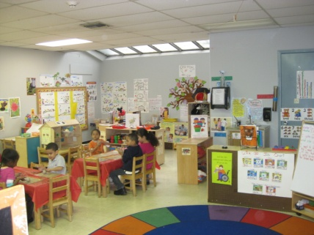
Curriculum:
The Belmont is a child’s laboratory for developmentally appropriate learning. It is a place where children can “learn to learn”, where they are encouraged to develop their curiosity, explore their interest and realize their creativity. The children at the Belmont are encouraged to discover the world around them through hands on activities in a well-developed environment that will foster open ended questioning and engage the children in meaningful conversation allowing for the development of social-emotional, physical, cognitive and creative thinking.
Through the early childhood experience our children gain independence, establish new relationships and learn to work and function in large and small group settings. The Belmont values play as an important medium for learning and has developed a broad range of developmental goals to focus on play. Through the combination of the Creative Curriculum, the Reggio Emilio Program, pieces of the Project Approach, and our own early childhood training the Belmont has created a well-organized developmentally appropriate early childhood curriculum. Educational planning is aligned with the Department of Education’s interdisciplinary units of study, common core learning standards, student interest, student needs and multicultural experiences.
This type of curriculum enables the individual child to develop and build upon their store of knowledge. The curriculum emphasizes communication, art, physical activity, literacy, and mathematical skills that are required for success in the primary grades, keeping aligned with balanced literacy standards and mathematical standards of the New York Department of Education. The Belmont’s curriculum grows and develops according to current studies, new strategies and the individual needs of the children we care for.
If you have any questions or concerns about your child’s development, please arrange a meeting with your child’s teacher and/or Director to discuss an individualized educational plan for your child.

How play helps a child’s mind to Grow
https://youtu.be/61yMFm40lIA

Interdisciplinary Units / Sub. Units
September– December  5 Senses  All About Me | January – March  5 Senses  Community | April -June  5 Senses  Life Cycles | July &August  5 Senses  Water
All About Me  Welcome to Pre-K  Babies | Where we live  Transportation  Light | Water  Plants  Transformation | Pizza  Sea Life
Welcome to Pre-school  School  Family  Culture  Routines  Holidays | Seasons  Culture  Community Workers  Land, Water, Air  Transportation  Safety | Weather  Plants  Fruits/ Vegetables  Animals Zoo/ Farm  Insects | Water  Animals  Body Parts

New York State Prekindergarten Foundation for the Common Core

Carefully developed early learning expectations linked to K-12 standards contribute to a more cohesive, unified approach to young children’s education. The learning standards provide a framework that focuses on the learning and development of the whole child and was inclusive of the broad academic concepts of the newly adopted New York State P-12 Common Core Learning Standards for English Language Arts, Science, Social Studies, Arts, Literacy, as well as for Mathematics.

The New York State Prekindergarten foundation for the common core is organized into five broad developmental and interrelated domains.
- Approaches to learning
- Physical Development and Health
- Social and Emotional Development
- Communication, Language, and Literacy
- Cognition and Knowledge of the World

http://schools.nyc.gov./Academics/CommonCoreLibrary

Prekindergarten Flow of the Day:

Greeting, Sign-In, Morning Routine, Free Play, Drawing
Teachers meet children and parents and exchange greetings
Children recognize and write their names
Children work with puzzles and games
Children express themselves through drawings
Instructional Family Style Meal (Breakfasts)
Full Meal Outlining CACFP guidelines
Children are responsible to serve and scrape themselves
Exploration Time Choice Time (Learning Centers)
Children are actively engaged in learning center activities.
The centers consist of Blocks, Dramatic Play, Math, Manipulative, Table Toys, Puzzles,
Sand and Water Play, Library, Listening Center, Art, Painting Wood Working, Science,
Computers, Light table, Felt Board.
The teachers, facilitating children’s involvement provides a balance of
Open-ended, child-initiated opportunities, alongside teacher-directed
Activities focused on projects of inquiry or theme-based activities for
Small groups of children.
Teacher interaction and observation
Hands on activities are also planned in small groups.
Cleaning up is supporting children’s Development
Class Meeting (Oral Language Development, Phonemic Awareness, Vocabulary, etc.)
Discussion About Exploration Time
Group Discussion
Understanding of Question and Answer
Collection and display of authentic Student work
Identifying future for next day’s exploration

Gross Motor Development and Music And Movement
Children have scheduled visits to the roof play area, the garden play area, code blue and the big playroom.
Children engage in both indoor/outdoor activities
Children engage in activities aligned with Pre-K standards across the curriculum
Children have a choice of directed group activities or free play
Children engage in dance, exercise, yoga, games and other
Gross motor activities.
Children learn new songs and get to work those large motor skills.
Integrated Sparks Program
Story Time
Teacher chooses one of a select approved group of titles to read to the children daily
Children will reread stories for multiple literacy reasons
Author studies will be conducted throughout the year
Children will learn to picture read
Read aloud and/or shared reading with interactive discussion
Teacher will supply children with another read aloud.
Teacher will provide this opportunity through puppets, flannel board,
masks and costumes for the children to dramatize these stories.
Children will act out and learn songs
Children will learn about poetry and learn to act it out as well.

Instructional Family Style Meal (Lunch Time)
Children and teacher eat a nutritious meal family style.
Discussion between adults and children addressing the meal, portion sizes, etc..
Children are responsible for setting, serving and scrapping their dishes
Nap Time
Children rest comfortably with their own sheets and blankets on individual cots
Soft music is played to help the children to relax and rest
3 year old’s 1hour and 15 min. – 4 year old’s 1 hour
Comfort devices such as teddy bears and blankets are welcome
Instructional Family Style Meal (PM. Snack )
Children and teachers have a small nap before the end of the day.
Children are responsible for setting, sewing and scrapping their dishes
Exploration Time II /Sensory Interaction/Library Time
Children chose centers (See above)
Children visit Sensory Areas located throughout the building where they are able to paint and create works of arts and crafts, and woodworking activities, engage in Sand and Water Play; make use of a light table
Children will have this time to look through the library and select any book they are interested in.
Children will use the skills they learn through mini lessons during circle time on book handling and usage.
The Educational Assistant can read to small groups at this time.

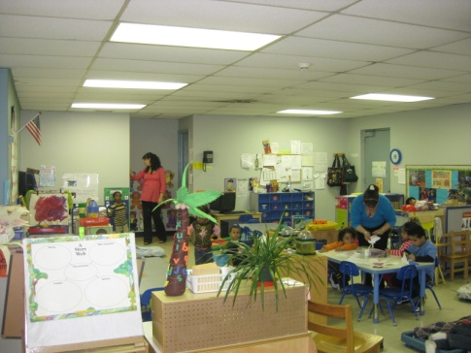
Children’s Assessment
The Belmont has an assortment of assessment tools that we use in order to record the progress of each child on an individual basis. Prior to the child entering our center there is an interview process with the director and the child’s future teacher. The parents are asked specific questions about their child’s interest, hobbies, personality and history. The child is present for this interview process. An open house is offered to all the parents in early September. The parents have an opportunity to meet once again with their child’s teacher and will receive a glimpse into their child’s daily routine. Throughout the year, three Parent Teacher Conferences are offered, where the teachers and parents can come together to discuss the child’s development and plan accordingly for the child’s needs. Teachers are available to speak with parents on a daily basis.
Teacher Parent Conference
November
March
June

Open Door Policy
The Belmont has an open door policy, allowing parents to come into the building to drop their children off, and to pick their children up. Parents are allowed to view their children during any part of the day after making arrangements with the director.
Screenings:

ASQ- Ages and Stages Questionnaire (3&4 year old’s)
Parents will be asked to complete a survey of developmental milestones for their individual child. This tool has allowed our teaching staff to obtain a clear picture of the individual child’s needs. By identifying the needs of the child, the staff has been able to prepare clear developmentally appropriate activities and a safe nurturing environment. A Parent questioner is handed out before the screening is conducted. Screenings are done within 45 days of the child’s start date.

ESI-R Early Screening Inventory Revised Edition 2008 (4 year olds)
The Belmont screens our children using the ESI-R. This tool has allowed our teaching staff to obtain a clear picture of the individual child’s needs. By identifying the needs of the child the staff has been able to prepare clear developmentally appropriate activities and a safe nurturing environment. A Parent questioner is handed out before the screening is conducted. Screenings are done within 45 days of the child’s start date.

PKBS – Preschool and Kindergarten Behavior Scales 2nd Edition Kenneth W. Merrell
The PKBS-2 was developed specifically for use with children in the 3 through 6 year age group. Its items are developmentally sensitive and specifically appropriate for use with young Children. The PKBS -2’s focus is on typical, general and routine social competencies and problem behaviors of young children that are commonly manifest in home and school settings. The two PKBS -2 scales (Social Skills and Problem Behavior) structure of the PKBS -2 allows for measurement of children’s assets and competencies and the problem behaviors.

Portfolio
Each child has a portfolio that they decorate at the beginning of the year. Throughout the year the teachers add work that expresses the child’s growth and development. These portfolios include drawings, paintings, pictures of activities and monthly observations that express the child’s thoughts and ideas about their work. The observations also include a space for the teacher to comment and
include a future goal for that individual child. The goals are developed to guide the child in their own learning process. Portfolios are to track student development and support growth throughout their Pre-K school year in each learning domain.

Observe

Ongoing Process
Document
What you observe
Use information to inform practice

Collect Student Work
Reflect on
Student Work

Daily Observations
Observations are written daily to track the child’s developmental growth. Observations are aligned to Pre-K Common Core learning standards. These observations help the educational staff to plan, write evaluations and develop a better understanding of the child and their individual needs. Teachers will record their plan of action and the child’s next step in achieving a specific goal. Classroom teachers meet weekly to discuss the children in their classrooms. Monthly meetings with the Directors are planned to discuss the children or can be scheduled as needed.

Creative Curriculum Gold – Teaching Strategies Gold

Children’s progress is aligned to Pre-K learning Standards that are developed from Developmental Milestones. Teaching teams plan to create a learning environment that is conducive to the children’s interest, social/ emotional, cognitive and physical development. The materials that are chosen are to encourage educational experiences through the art of play. The teaching teams observe the children during their daily interactions with these materials and scaffold their development accordingly. Teaching teams use the standards as a guide in proper preparation of what skills children will need in preparation for kindergarten.

The Teaching Strategies Gold System assists teaching teams in keeping their observations organized and aligning each interaction with developmental standards to accurately track children’s progress.
These formal and informal assessment tools will be placed in your child’s portfolio and shared with parents during Parent / Teacher conference.

dev-cont.pdf (haddonfieldschools.org)

NYS_Prek_Learning_Standards-2019.pdf (earlychildhoodny.org)

Special Needs
The Belmont’s administration supports and supplies parents with the materials they need for special services. Children who need evaluations are referred to the proper organizations for assistances. Our teachers are knowledgeable about early intervention services and the IEP process.

Services:
- Thera Care 718-597-5558
- New York Therapy 631-473-4284
- Department of Education 1 Fordam Plaza #7 Floor
- Rose Kennedy 718-430-8900
- Bilingual Site 718-353-2330
Social Services and Counseling:
The Belmont works in collaboration with the Department of Education, The Rose F. Kennedy center, ACS and New York Therapy. The Belmont works through a referral process, helping our families receive the necessary services.
Resource Guide
New Alternatives for Children
37 West 26th street
New York, N.Y. 10010
212-994-7917

Resources for Children with Special Needs
116 East 16th Street, 5th Fl
New York, N.Y. 10003
212-677-4650

Learning Disabilities Association of NY
27 West 20th Street
New York, N.Y. 10011
212-645-6730

Department of Education
1Fordham Plaza 8th floor
Bronx N.Y. 10458
718-

New York Child Resource Center
348 East 146th street
Bronx N.Y. 10451
718-585-5669

TheraCare
3250 Westchester Ave
Bronx N.Y. 10461
718-597-5558

Children’s Evaluation and Rehabilitation Center
Albert Einstein College of Medicine
1731 Seminole Avenue
Bronx, N.Y. 10461

Family Mental Health and Early childhood
Education Plan

Cognitive Screening Tool
Screening
Authentic Assessment
Authentic assessment systems are a formative collection of qualitative student data (i.e. student work, teacher notes) that measure student performance and progress across multiple academic disciplines along a continuum. They help teachers monitor students' developmental progress over time while informing curriculum and instruction.
Authentic assessments are based on teacher observation notes and student work samples gathered in the context of everyday classroom activities and experiences. This information is collected over time and across multiple domains of development, providing a comprehensive view of the child's learning and progress. Published authentic assessment tools provide teachers with frameworks to:
- Strategically collect observational data and student work samples
- Analyze that information along a developmental continuum
In this way, published authentic assessments capture information about students' individual knowledge, skills, performances, and approaches to learning. Teachers can use this information to monitor students' development over time and inform curriculum and instruction.
Model:
  - Teaching Staff
  - Educational Director
  - Parent
  - Community / Intra-Agency Partner
Process:
- ASQ is Administered by Teachers within the first 45 days of entry into the Program
- Parents fill out and return Parent Survey Form
- Rescreening are discussed at first Teacher Team Meetings with the Educational Director
Screening tool, Classroom observations and Family information report are reviewed, and suggested referrals are made
- Parent Meetings will be arranged, and referrals will be discussed with parents
- Information will be providing to different testing sites.
- Continued Support will be given to families regarding Individual Family Service Plan or Individualized Education Plan
- Teachers and SEIT’s will work closely in and out of the classroom
- Parents will receive a Parent Letter stating if their child has Pass, Re-Screen or Refer
- Re-Screenings take place 6-8 weeks after initial screening
Pre-school Behavioral Scale

Summary of PKBS-2
The PKBS-2 is divided into two different scales:
- Social Skills Assessment (34 items): This scale describes the positive social skills that are characteristic of well-adjusted 3 to 6 year old’s.
- Problem Behavior Assessment (32 items): Addresses problem behaviors commonly seen among children of same age group
Unique Features of the PKBS-2
- The scale was developed specifically for use with children ages 3 to 6 as opposed to a downward extension designed for older children. (pp. 2)
- Using comfortable terminally. Focuses on typical and general social competencies and problem behaviors as opposed to other tools that are highly clinical and focusing more on specific psychological symptoms.
Purposes of PKBS-2
- Identify pre-school children who exhibit high-risk behaviors and may benefit from early intervention.
- As a component for identifying children who can be eligible for services.
- To help assess deficiencies in social skills and behavior problems top help develop appropriate interventions.
- A measurement tool for monitoring children’s behavior changes during course of intervention and to evaluate effectiveness of said intervention.
- As a research tool.

Model #3

- Mental Health Consultant
- Community/ Intra-Agency Partner
- Staff

Process:
Staff
- Conduct Training Staff /Parenting
  - Teaching Staff administer ESI-R and PKB-S-2 to children within 45 days

Mental Health Consultant:
- Follow up Screening Results
- Attend Multidisciplinary Meetings
- Provide Classroom Support
  - School Psychologist will review Screenings, meet with teachers and conduct classroom observations
  - School Psychologist will meet with Educational Director to discuss children who need additional services
  - School psychologist, Educational Director, Teacher and Parents will meet to discuss next steps
  - Referrals will be made and information to appropriate testing sites will be shared
  - School Psychologist will supply technical support to classroom teachers
Community Partner
(Student)
- Conduct Child Observations
  - Agency will be supported by teaching staff to conduct observations and share developmental information about the individual child
  - Observations and Evaluations will be shared

Intra-Agency Partner
- Provide Crisis Intervention
  - Staff and administration will support the child and family with the appropriate services that are needed.

Documentation

- Parent Surveys are given out
- Screenings are administered utilizing screening tools
- A Log will be kept of children’s results for ESI-R and PKBS
- Screenings will be reviewed by school psychologist
- Parent information letters regarding Screening results are handed out
- Parent Meetings are scheduled to discuss children who need additional services
- Referral Letters will be handed out
  - ASQ Educational Director
  - PKB-S School Psychologist
- Child Health Record will be filled out for each Child
- IEP and IFSP will be kept in children’s file and will be reviewed Periodically
- ESI-R results will be implemented into the Pre-Kids system

Department of Education – Additional Educational and Mental Health Services

The Department of Education is providing The Belmont Community Day Care center with a Early childhood consultant and a Social Worker. She will be working directly with teachers to build safe nurturing predictable classroom environments, to help children recognize and handle their feelings and to help manage challenging behaviors when they arise in the classroom.
She will also work with families throughout the year. Social worker is always available to speak with you about any developmental or educational questions you may have and is happy to support a referral process for additional services when needed.

Meeting the Needs of Dual Language Learners

The Belmont community has a number of Spanish Speakers. To accommodate these families, we supply all letters and memos in both English and Spanish. Our classroom teaching teams are made up of English and Spanish speaking staff. Our children and parent library have an assortment of books in Spanish and English. Our Administration consists of English, Spanish, Albanian and Italian speakers.

Our site collaborates with - Bilingual SEIT 718-353-2330. Bilingual SEIT offers assistance to dual language leaner’s and their families.

Belmont has a 90/10 program. Classroom instruction is offered in both languages, encouraging students to learn both languages. Classroom environment is reflective of both languages, (materials are labeled in English/ Spanish, the flow of the day is identified in both English/Spanish, books in English and Spanish are available.

“The Test of morality for a society is what it does for its children” -Dietrich Bonhoffer
Family Involvement
Parental relationships and involvement are mutual objectives of the Belmont Community Day Care Center and its Parents. All parents are members of the Parent Advisory Committee (PAC) and are encouraged to establish active communication with other parents. The PAC works closely with the Director and staff to establish training sessions, such as child health and development issues. We encourage parents to attend these meetings and seminars. The staff at the Belmont takes great care in arranging special educational events for the children throughout the year and the Parent’s association provides support in raising additional funds.
Parents Association Committee assists with the following fund raisers: Scholastic Books, Penny Harvest, Monthly Raffles etc. They have several foods, clothing and toy drives throughout the school year.
Each Year new parents join an extensive committee of Belmont Alumni contributing to decision making in regards to policy, procedure, health and safety requirements and educational changes. The Committee meets four times during the school year, to assist the current PAC with planning and decision making.
Fund Raising
Throughout the year the families of the Belmont are required to participate in several fund raising activities. All funds raised are used solely for instructional trips and educational activities.

  - Penny Harvest
  - Scholastic book Fair
  - Movie Nights
  - Family Nights
  - Egg Hunt
  - Holiday Raffle
  - Pasta Night

Our Families are very important to the dynamics of our center!

Parents get Involved

The Parents get involved program enables parents to share their occupations, talents, and culture with all the children in the class. Parents can share their occupations, read to the children, and engage in sharing cultural experiences through food, dress, pictures, etc. Sign up will be with your child’s teacher.

Parent Trainings and Workshops
Each September a survey is handed out, and we request input from our families, so we can have suggestions and feedback for classes, trainings and workshop that interest them. The Belmont offers parent workshops for cooking in the evening on a monthly basis offered by the Department of Health Eat Well Play Hard Program and Cornell University. The Belmont works in collaboration with St. Barnabas Hospital, which supplies a number of trainings, educational workshops and free test throughout the year. Studio in a school offers two art workshops for parents and children. The Belmont Staff supplies a number of workshops and family events throughout the school year.
Family Room
Our program has a comfortable family room that is open to all our community and family members. A variety of reading materials, covering an assortment of educational and current topics are made available. Suggested materials for family outings, educational historical museum and sites are offered. Family interviews are conducted in this space to give the teaching staff a better understand of the family and children we are servicing. A Family interview will be conducted twice a year. During these interviews, your family will sit with our teaching staff and fill out a detailed questioner to get a better understanding of your parenting tactics and any assistance you may need. Our staffs are trained professionals and all material is confidential.
Belmont Community Mission Statement and Goals on Family Interview process
- Helps parents enjoy a lead role in guiding their children’s development
- Adjusting their approach for a wide range of families
- Work successfully with interpreters, translators, and special needs providers
- Communicate in a warm, accepting, respectful and empathetic manner
- Conduct effective assessment in the child’s natural environment
- Implement evidence; based interventions that fit the child’s needs and help each unique family meet their goals
- Work with children with specific disorders, such as autism, delayed speech, and language, and developmental delays
- Skillfully manage legal ethical and personal safety concerns

Belmont Community Day Care Center
2340 Cambreleng Avenue
Bronx N.Y. 10458
718-584-1576

Name: _____________________ Date:_________________

Child’s Name: __________________

Class: ________________

Parent Survey

Please circle topics of interest:

Training Topics
Creative Curriculum Ages and Stages
Organizational Skills Family involvement
Home Visits Cooking class
Eat Well Play Hard Aerobic Workout
Brain Development Teen Moms
Health and Mental Hygiene Importance of Literacy
Ethical Behavior Math
Nutrition Pre-K Standards
Multiple Intelligences Yoga
Developmentally Appropriate Practice ESL
Mommy and Me Dance
Feeling good about me Pregnant mother’s
Zumba Anger Management
Daddy and me Substance Abuse
Self Help Classes Arts and Crafts
Lead House Hold Tips
Communications Family Therapy
Are You in a Health Relationship? Importance of Physical Activity
Obesity Diabetes

Suggestions:

- Are you interested in joining the (PAC) Parent’ Association Committee? Yes No

- Are you interested in joining the Board of Directors as a parent member? Yes No

- Are you interested in assisting with family fundraisers and special events? Yes No

Parents get Involved

The Parents get involved program enables parents to share their occupations, talents, and culture with all the children in the class. Parents can share their occupations, read to the children, and engage in sharing cultural experiences through food, dress, pictures, etc. Sign up will be with your child’s teacher.

- Are you interested in Participating in the Parents Get involved program? Yes No

Workshops and trainings are open to the community.

Thank You

Sincerely,

Belmont Staff and Administration

Cool Culture
Cool Culture is based on a simple premise: family visits to cultural institutions educates and inspires young children. We believe more families and children should benefit from the educational value of cultural institutions in our City.
Over 25% of New York City’s youngest children have unmet development needs. Most of Cool Culture’s participating families live in the City’s most underserved areas. At the same time, the City’s museums, historic societies, science centers and zoos have enormous educational resources designed by top-notch educators.
For over 10 years, Cool Culture has connected low-income families to cultural institutions, providing educational opportunities that involve the entire family and develop young children’s curiosity and love of learning.
http://www.coolculture.org/
Book of the Month
The Belmont believes that reading is the most important gift that we can give to a child. Each month the Belmont has chosen a book to concentrate on with our children and families. The Book of the month is our way of sharing ideas about literacy throughout our building. The following books have been chosen for this year and you can find the children’s work around these books on the communal bulletin board in the main lobby.
- Llama Llama Red Pajama September
- Pete the Cat October
- Leaf Man November
- Caps for sale December
- The Snowy Day January
- A Letter to Amy February
- Green Eggs and Ham March
- The Tiny Seed April
- Click Clack Moo Cows that Type May
- The Night before Kindergarten June

Belmont Parent and Child Events
Month | Event | Place | Time | Participates
September  Parent event | Parent Meeting | Belmont | 4:30-6:30 | All Staff
October  Parent Event | Open House | Belmont | 9:00-11:00 | All Staff
October  Parent Event | Parent Workshop | Belmont | 9:00-3:00 | All Staff
September  Parent Event | Daddy Bring your child to School Day!! | Belmont Courtyard | 7:30 am-8:30 am | All Staff
October | Trunk a Treat |  | 10:30-11:30 | All Staff
October  Childs Event | Pumpkin Picking | Belmont Garden | See Schedule | Teaching Teams
October  Childs Event | Apple Cider Press | Belmont Courtyard | See Schedule | Administration / Team Teaching
November  Parent Event | Scholastic Book Fair | Belmont Court Yard | All Day | Administration
November  Childs Event | Turkey Feast | Playrooms | 11:00-1:00 | All Staff
November  Parent Event | Grand Parents Day | Belmont Courtyard | 7:30am-8:30 am | All Staff
December  Childs Event | Muscle Man Mike Show | Big Room | TBA
December  Childs Event | Santa Comes to Belmont | Big Room | TBA | All Staff
January  Parent Event | Teddy Bear Curriculum | Big Room | TBA | All Staff
March  Childs Event | Muscle Man Mike Show | Big Room | TBA
April  Childs Event | Egg Hunt | Belmont Garden | 9:00-12:00 | All Staff
May  Parent Event | Scholastic Book Fair | Belmont Courtyard | All Day | Administration
June  Parent Event | Moving Up Ceremony | TBA | TBA | 4-K
June  Child Event | End of year Class BBQ | TBA | TBA | All Staff

Belmont Community Day Care Center / Policy and Procedure
Medicals:
Each child that attends the Belmont Community Day Care Center must have a completed Medical Examination Form on file. This form must be updated on yearly basis. Also on file is the child’s updated immunization record. Any child who doesn’t have an updated medical form will not be
able to attend.
Medical Needs to include the following: All updated vaccinations
Lead assessment Polio Flu Shot
DTP Varicella
MMR HBV
Hib Dental
(Department of Health Regulation)
Asthma Action Plan
Parent Questioners needs to be filled out by each parent and depending upon the results of the questioner an asthma action plan form will be filled out by the child’s doctor and will be placed in the child’s medical folder.
http://www.health.ny.gov/publications/4850.pdf
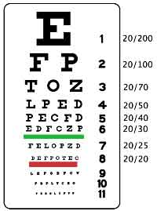
Vision and Hearing Services:
The Belmont Community Day Care Center Participates in a vision and hearing screening test each November that is conducted by the Department of Health

Epinephrine auto-injectors:

  - Epinephrine auto-injectors are devices used to deliver emergency medication when children or adults have life-threatening allergic reactions. Programs will be required to have two epinephrine auto-injectors on site, and at least one staff person trained to recognize the signs of anaphylactic shock and to administer epinephrine must be on site whenever children are present. It is recommended that at least two staff members be trained.
  - The epinephrine auto-injectors have been donated by the pharmaceutical company, Kaléo, for the first year of the requirement and will be provided for free to programs that present proof of training.
  - Details about training requirements and submitting proof of training to qualify for two free auto-injectors will be emailed to you soon.

MAT Certification:

  - Medication Administration Training (MAT) certification will no longer be required to administer a child’s asthma inhaler or nebulizer or epinephrine auto-injector as long as there is written consent from a parent and health care provider, and the parent provides training.
  - Details about this change to promote child health and safety will be sent shortly.

Escort Policy:
During the intake process the child will receive hours based on the work schedule of the parents. Proof of working hours is required. At this time the Director will assign the individual child care hours. Children shall not be left at the Day Care Center before official opening time (8:00 am) or without appropriate staff to receive them. All children must be picked up by their official time. It is the responsibility of the parent to designate appropriate escorts and to provide the Day Care Center with the names and telephone numbers of at least two responsible relatives or friends who may be contacted to pick up the child in the case of an emergency or when the parent or guardian is unavailable.
If any escort arrives after our closing time, the appropriate fee will be charged. Labor Laws dictate that teachers need to be compensated for time beyond their normal work schedule. The city does not allow for such compensation in our budget, forcing it to become the responsibility of parents. Under no circumstances will this fee be waived. If you will be late picking up your child, please notify the center but also realize that the fee will remain your responsibility. The late charge will become part of your fee due on Mondays. Any escort picking a child up after 6:00 pm will incur a fee of $1 per minute.
Children will only be released to the escorts listed on their white/blue card. Parents are able to list as many escorts as they feel necessary, however phone calls about changing escorts or adding escorts will not be permitted. Authorized responsible escort must be at least eighteen (18) years of age. Escort must be designated by the parent in the writing on their white or blue card. Day care staff will not release a child to any individual who has not been designated by the parent. Only the parent’s/guardian of the child can alter escort information after the intake process.
In accordance with regulations and in order to provide for the security and welfare of your child, all persons bringing children to their classroom and picking them up will be required to sign a book which will be in your child’s room.
You or the child’s escort will provide the following:
- Your child’s name
- The time the child is brought in or picked up
- Your signature or the that of the escort (Legal Names)
Release of Children to Authorized Escorts (47.57(h) (1))
- Keep a list of names, relationship to the child, address and contact information of all people authorized by parents/ guardians to escort children from child care.
- Do not allow a child to be released to an unauthorized escort.

Transition and Continuity:
The Belmont has implemented the following procedures for a smooth transition period allowing the children to feel safe and comfortable at all times. Children are given individual cubbies that belong to them for the year to store their belongings. The first five days the child’s hours are 9:00-1:00 to help them adjust to the full day and classroom routines. Parents are encouraged to stay and spend time with their children in the classroom setting. A meeting is arranged between the parent, child and teacher prior to the child’s first day. A child’s history form is filled out prior to the child beginning the program. Children are welcome to bring materials from home, such as pictures, a favorite toy or blanket to help with the transition process. Our teachers are trained to create a welcoming, nurturing and safe environment.

Photograph Release form:

I, the parent guardian of __________________________ in class_______________________ give permission to the Belmont Day Care Center to photography my child,
______________________________, during the course of the school year. I understand that those photographs are to be used exclusively for professional development and/or for publication in an education magazine or education web site and that at no time will the photographer receive any payment for these pictures.
Instructional Staff Development Days:
The Belmont Community Day Care Center is greatly committed to the professional maturity of the center’s staff and is conscious of the importance of development and training to provide a quality program, which meets all program goals. Our staff attends professional trainings, in service trainings, and local conferences. The center organizes four professional staff development days per year in addition to the numerous staff workshops that are offered by UPK, ACS, DOH, DC1707 and CACFP. On a monthly basis staff members attend 4 to 12 trainings. Trainings are decided by the staff’s individual needs.
Twelve days a year the building is closed for staff development days and alternate child care needs to be arranged for your children on these days. A notice during the interview process will be given and a
second reminder will be given by the classroom teacher. Notices will go home as reminders weeks before the closing.
- See Calendar

Transition to Kindergarten

Transition to Kindergarten is an important time for all our four-year old’s. The Belmont Staff, Administration, and parents work hard to make this transition as easy as possible for our children. The Belmont works closely with our surrounding public schools who allow our pre-K children to visit their facility and meet with their future teachers. Our afterschool children come to speak with our Pre-K children to share information, answer questions and support them. Kindergarten preparation materials are distributed and our teachers incorporate literacy and group discussion that encourages and supports our children preparing them for the next educational phase of their lives.

Transition Process
Pre-K to Kindergarten
Time Line: September – June

September – Attending Pre-K
December – 2nd Step – Zone school information and other options (charter school, Private School : http://www.nyccharterschools.org/content/icahn-charter-school-2
January -3rd Step – Assistance with kindergarten application for Public Schools www.nyc.gov/schools/kindergarten ---
January – 4th – Step – Teddy Bear Curriculum- Teddy Bear Creation – Transition Friend – Family Involvement Activity.
January – June – 5th Step – Discussion and Literacy Connections
May – 8th Step – Visit to the Local Kindergarten (Children)
May- 9 Step Question and Answer with Belmont Alumni (Children)
June – 10th Step – Public School Orientation (Parents)
May/ June – 11th Step – Wrap up and drop off of student files to school’s.


Payments and Fees:
Fees are determined by family income on a sliding scale and are to be paid on weekly basis. You will be expected to leave your payment with the bookkeeper and sign to verify that a fee was paid for your child. Receipts for payment will be available during the week. If fees are not paid as required on weekly basis, your child will not be permitted to attend class the following Month.

In complying with our contractual obligation with Administration for Children Services, fee payments are being changed to tuition based payments, effective September 1, 2013. This means if a child is absent for a full week payment in full is still required for that week. If a child will be away for more than two weeks and you wish not to pay you must request that your child be discharged in order not to pay the tuition. Upon return you can reapply to ACS to reinstate your child. If there are no available slots at Belmont Day Care Center, ACS will inform you of other day care centers with open slots.

Materials:
It is very important that your child feel comfortable during his/ her stay in daycare. Your child is required to have a clean sheet and a clean blanket each week. These blankets and sheets should be the appropriate size and they should be taken home and cleaned each weekend. Any extra emergency sheet should be left in the classroom at all times. A weather appropriate change of clothing should be supplied and remain in the child’s cubby in case of any “accidents” throughout the day.
Your children should attend daycare in comfortable fitting clothing that will allow for movement and play. The main goal for your children during their stay at the Belmont Day Care is for discovery and
exploration. Discovery and exploration can become messy at times, so the appropriate clothing is needed for learning.
List:
1. Comfortable Clothing/ Slippers
2. Sheet and Blanket
3. Emergency Blanket
4. Weather Appropriate Change of Clothing

Mandated Reporters
As mandated reporters, Belmont Staff are required under the penalty of the law, to report to the New York State Child Abuse Registry any suspicion of a child being physically, emotionally, or sexually abused and or neglected; including indifference to physical, medical, educational, or psychological needs.
I understand that in the event that my child arrives at Belmont with bruises or marks, that my child reports abuse or neglect, or that my child indicates that abuse or neglect has taken place; this will be
promptly reported as required by law to the New York State child Abuse Registry. I understand that such a report will necessitate a visit to my home by a worker from the administration for Children’s Services who will evaluate the situation and take action, if they deem it necessary.

Attendance
It is important that your child attend Day Care on a daily basis. If for some reason your child is unable to attend day care please call the front desk at 718-584-1576, to inform the administration that the child will not be in. Doctor’s note is required for a number of days out and highly contagious situations. Your child’s health is important to their development. If your child will be out for more than a week on vacation, please make your child’s teacher as well as the front desk aware. Children are not to exceed 12 days in one month and 24 days in a 6 month period.
It is important that each day parents and or escorts sign their child in and out of the building. Authorized Daily attendance logs are located at the front of each classroom. It is imperative that you practice this each day with the proper information. All escorts are to sign their legal names, as well as the legal name of their child. The document also requires the time you are dropping the child off as well as the time you are picking the child up. Daily Attendance Records (47.27(a))
- Maintain daily attendance records that include each child’s name, arrival Time and departure time.
Absences
Children who are absent from our program are called on a daily basis and the reason for their absences is recorded. Parents are required to attend parent meetings as well as parent workshops that are held throughout the school year.
Child Absence (47.27(c)(4) and (d)
- If a child is unexpectedly absent, notify the child’s parent/guardian of the absence within one hour of his/her scheduled arrival time by telephone, text, e-mail or other means of immediate communication. Maintain records of all parental/ Guardian notification attempts and any contacts.
- In order to comply, maintain Parent/Guardian contact information on file and request that parents update it immediately when there are any changes.
- When parents are first enrolled, inform parents that they must notify the center of any unscheduled child absences no later than an hour after the scheduled arrival time.

Communication Devices

Facebook

Please join the Belmont family on Facebook. Information will be posted, and updates will be made weekly. This is a great way for our families to share information.

www.facebook.com Search for Belmont Community Day Care Center!

Email Address

bcdaycare@verizon.net
or
Belmontdaycare@gmail.com

Belmont Website

Belmontdaycarecenter.com

Blog

www.praxis187.blogspot.com

Twitter

TBA

Phone #
718-584-1576

Fax #
718-584-4443

Remind App

Connect with your child’s teacher. Up Coming Events, Parent Information, follow-up of student activities and learning opportunities throughout the day.

11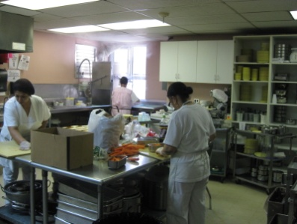

Instructional Meals:
Nutrition Services
The Belmont Community Day Care Center receives funding from the United States Department of Agriculture (CACFP), which enables us to provide well balanced meals for all the children that attend the day care. There is a morning snack, a hot lunch and for full time attendees there is a supper. All meals are purposefully planned and prepared, always adhering to the nutritional guidelines and standards set forth by the USDA. The children enjoy the home cooked meals that are prepared for them by our onsite kitchen staff. Our kitchen staff members are certified food handlers. Preschoolers benefit from an introduction to a variety of fresh foods that encompass all the essential food groups. Meals are served family style in the classroom, where staff and children sit together and enjoy lunch. Children are responsible for serving and cleaning up their settings.
A weekly menu hangs in the main hallway.
Example:
Monday | Tuesday | Wednesday | Thursday | Friday
Grape Juice  Crispy Unsalted | Corn  Flakes/Milk1%/Bananas  Apple | Oatmeal Cookies  Orange Juice | Social Tea Cookies  Pineapple Juice | Pancakes  Grape Juice
Pasta With Chick  peas  Carrot Strips  Hard Boiled Eggs  Milk 1%  Italian Bread  Apples | Chicken Cutlets  Baked Potato  Tossed Salad  Milk 1%  Whole Wheat Bread  Pears in syrup | Egg Salad  Cucumber and  Tomato  Salad  Milk 1%  White Bread  Jell-o with fruit | Fixed Hamburgers  on a Bun / Pickles  Vegetarian Beans  French Fries  Apple  Milk 1% | Fish Sticks  Broccoli Spears  White Bread  Milk 1%  Peaches in syrup
Tuna Salad Sandwich  on Whole White  bread  Celery Strips  Milk 1%  Bananas. | Macaroni and Cheese  Spinach  Cheese Platter  Milk 1%  White Bread  Orange | Chicken Stir-Fry-  Vegetables  Rice with Butter  Milk 1%  Italian Bread  Apple Sauce | Turkey Sandwich  Tomato Salad  Milk 1%  Whole Wheat Bread  Fresh Pears | Peanut Butter/Jelly  Sandwich  Cucumber Strips  Milk 1%  White Bread  Orange Sections

No food, drinks or medication are allowed to remain in the children’s cubbies. This is important for the safety of all the children. Water is provided to the children throughout the day. Water bottles are not permitted in the classroom or cubbies. (Department of Health Regulation)

November 4, 2010

Nutrition at Belmont

Early childhood is a critical time for cognitive, social, physical and motor skill development. By adopting these recommended practices child care centers will:

- Contribute to child health and help prevent chronic diseases such as type 2 diabetes and heart disease
- Supplement nutrition in the home and community
- Include opportunities for physical activity

All parents want their children to be healthy. As children go through remarkable physical changes of all kinds, their food intake becomes a critical aspect of this growth and development. Recent research shows that nourishing food not only makes a child healthier, it makes him/her emotionally more stable, and it improves their physical, social and cognitive development.

It is important that we supply a healthy learning environment for our children enabling them to engage in healthy eating that will foster their development. We are asking that all parents model healthy eating at home to the best of their abilities and we are going to practice healthy eating as part of our daily routine at the Belmont. Moving forward we will not allow food with little or no nutritional value to be served (for example, potato chips, cookies, cheese doodles, etc.) If you bring in non-nutritional foods we will not serve them to the children. We will keep them on the side and return them home with you.

During special occasions such as holidays and ceremonies the following is suggested:
- Healthy items such as vegetables and low-fat dip, fruit slices, and low fat cheese and whole grain crackers, should be provided.
- Physical activities such as games and dancing should be promoted during special occasions.

Healthy Suggestions:
- Fruits and Vegetables
- Celery and peanut butter
- Muffins
- Apple Slices
- Low Fat yogurt,
- Low Fat cheese
- Whole Grain Crackers
- Breadsticks
- Smoothies
- Frozen yogurt cake
- Banana Sundae (bananas, low fat vanilla yogurt and crushed cereal)
- Fruit Kabob
- Chick Pea Deep
- Hummus
- Spinach Dip
- Cottage Cheese and fruit
- Tortilla with low-fat refried beans
- Frozen Fruit Juice on a popsicle stick
- Banana Chips

Suggested Activities Parents could do at home in order to model a healthy life style:

- Increase developmentally appropriate activities
- Decrease exposure to television and other recreational screen time
- Increase consumption of vegetables and fruits
- Increase consumption of low-fat or fat-free milk, for children over the age of 2.
- Increase the initiation and duration of exclusive breastfeeding
- Read food labels/ check sugar and sodium amounts
- Eat Family style each evening
- Talk and encourage healthy eating
- Limit eating out
- Eat three meals a day
- Take a walk each evening
- Participate in activities and play games

Nutritional Parent Workshops

Nutritional workshops are offered each month at the Belmont Community Day Care Center on scheduled days in the evening. Nutritional Workshops are offered by a nutritionist from the (CACFP) Eat Well Play Hard Program and Belmont Staff. Please come and participate.

Healthy menus and information are handed out monthly and posted in the main hallway.
Parent and Child magazines are given out monthly and include articles regarding healthy eating, nutrition, menus and exercise.

Informative Websites:
- www.americaonthemove.org
- www.fruitsandveggiesmorematters.org
- www.fsis.usda.gov
- www.mypyramid.gov
- www.cfsan.fda.gov
- www.nyhealth.gov/nutrtion
- www.nal.usda.gov/wicworks/
- www.choosemyplate.gov

Informative Materials:
- Growing Healthy Children
- Eat- Play –Grow
- Move-to Improve
- Sparks

Birthday Parties:
Children are supplied on individual birthdays to where a hat or pin to signify the special day. On the last Friday of the month the program this class with a small treat to celebrate. This policy assist with nutritional regulations and prevents food allergies.

Obesity Data

- Obesity Rate in the Bronx:
  - In the Bronx, about 35-40% of adults are classified as obese, which is significantly higher than the national average of about 30%.
  - Among children, particularly those in low-income areas, the obesity rate is similarly elevated, with an estimated 20-25% of children being obese.
- Obesity Rate Among Children:
  - As of the most recent data, approximately 24% of children ages 6 to 11 in New York City are considered obese. This number tends to vary by neighborhood and socioeconomic status, with some areas seeing even higher rates.
- Disparities by Borough:
  - The Bronx has the highest obesity rate among children, with more than 30% of children in the borough classified as obese.
- Health Disparities:
  - The Bronx is often highlighted as one of the boroughs with the highest rates of obesity, in part due to a combination of socioeconomic factors, limited access to healthy food options, and a lack of safe spaces for physical activity.
  - Certain neighborhoods in the Bronx also face higher rates of food insecurity, which can contribute to poor nutrition and weight gain.
- Risk Factors:
  - Health outcomes related to obesity in the Bronx include higher rates of diabetes, hypertension, and heart disease.
  - The Bronx has a particularly high rate of Type 2 diabetes, which is directly linked to obesity. The borough's adult diabetes prevalence rate is about 15-20%.
- Efforts and Initiatives:
  - The Bronx has seen various initiatives aimed at improving access to healthy food, such as urban gardening projects, farmers' markets, and nutrition education programs.
  - Local health organizations have also been working on increasing physical activity opportunities, such as walking groups, fitness classes, and improving public parks and recreational areas.

Benefits of Family-Style Eating
For children and families, there are multiple documented and reported benefits:
- Nutrition / Health
  - Children who eat family meals tend to consume more fruits, vegetables, fiber, and nutrients like calcium, vitamins etc. Johns Hopkins Medicine+2blog.jumpinforhealthykids.org+2
  - Also associated with lower risk of overweight/obesity in children. www.heart.org+1
- Social, Emotional, and Cognitive Development
  - Helps with developing social skills: taking turns, patience, sharing, conversation. blog.jumpinforhealthykids.org+3Bright Horizons+3New York State Department of Health+3
  - Enhances language skills (talking about dishes, flavors, smells, etc.), table manners. New York State Department of Health+1
  - Builds self-esteem in children by giving them choice and some autonomy over serving themselves. New York State Department of Health+1
- Behavioral & Lifestyle
  - Encourages healthier eating behaviors. Children are exposed to new foods in low-pressure settings, which can help reduce food neophobia (fear of new foods) or picky eating. Food and Nutrition Service+2blog.jumpinforhealthykids.org+2
  - Improves family bonding and communication. Mealtimes become occasions for connection. www.heart.org+2Johns Hopkins Medicine+2
- Self-regulation of portion and choices
  - Children learn to decide how much of each food they want, start noticing hunger/fullness signals. blog.jumpinforhealthykids.org+1

How to Implement Family-Style Eating
Here are some practical tips for homes / childcare settings:
- Start small / gradually
  - Begin with one or two meals a week served family-style.
  - For younger children: use smaller serving bowls/pitchers, simple utensils. New York State Department of Health+1
- Include children in all steps
  - Let them help set the table, serve themselves, pass dishes, clear up. Gives ownership and helps learning. New York State Department of Health+2fromtime2time.com+2
- Model behavior
  - Adults should eat together with children, show them how to use utensils, how to taste, talk about food, etc. Food and Nutrition Service+1
- Offer choices
  - Offer multiple foods at the table, some familiar, some new. Let children choose which ones. Food and Nutrition Service+1
- Set peaceful & interruption-free atmosphere
  - Reduce distractions (TV, phones). Create a pleasant setting. Mealtime is about connection, not just eating. www.heart.org+1
- Rules / routines
  - Basic expectations like washing hands, waiting turns, trying “just a bite,” saying please/thank you etc. Helps structure the meal in a predictable, respectful way.
- Watch for portion cues & hunger signals
  - Encourage children to start with smaller servings and take more if hungry; help them sense fullness to avoid overeating.

Healthy Nutritional Habits
- Eat more plants
  - Fill half your plate with fruits and vegetables.
  - Include legumes, nuts, seeds. These plant proteins are lower in saturated fat.
- Choose whole and minimally processed foods
  - Whole grains instead of refined grains. Think brown rice, whole wheat, oats, quinoa.
  - Avoid or limit ultra-processed foods (fast food, many packaged snacks, etc.) which tend to have more added sugars, sodium, unhealthy fats.
- Limit sugar, saturated fat, and sodium
  - Reduce added sugars (sodas, baked goods, sweetened beverages).
  - Use healthier fats (unsaturated fats such as olive, canola, etc.), limit saturated fats (butter, full-fat dairy, fatty meats).
  - Cut down on salt / high sodium foods (processed, canned, restaurant meals).
- Eat enough protein from varied sources
  - Lean meats, poultry, fish; also plant proteins like beans/legumes, tofu, nuts.
  - Distribute protein across meals (not just one big protein meal).
- Portion control and mindful eating
  - Be aware of portion sizes; try not to over-serve. Use smaller plates if helpful.
  - Eat without distractions (like TV or phone), chew slowly, notice signs of hunger and fullness.
- Plan ahead
  - Meal planning, cooking at home. Makes it more likely you’ll eat well.
  - Grocery list, prepping snacks or meals. Reduce impulse eating.
- Hydrate well
  - Drink water regularly; limit sugar-sweetened beverages.
- Variety & color
  - Aim for colorful plates: different fruits and vegetables. Different colors generally mean different nutrients.
  - Try new foods; rotate different types of produce or protein sources.
- Include foods that support bone, heart, and metabolic health
  - Calcium & Vitamin D rich foods. Dairy, fortified alternatives, leafy greens, certain fish.
  - Omega-3s (from fish, nuts, seeds). Healthy fats.
- Make it sustainable, culturally relevant, joyful
  - Food should also be satisfying and fit your lifestyle. If an eating plan is too restrictive, it’s hard to maintain.
  - Incorporate foods you like, meals from your culture, ways of eating that feel meaningful.

Self-Help Skills
Self-help skills are tasks that children can do by themselves (or with decreasing support), that help them manage their daily needs, develop independence & confidence. Often called “activities of daily living” (ADLs).
Categories include:
- Personal hygiene (washing hands, brushing teeth, using tissues)
- Dressing & grooming (putting on clothes, shoes, jackets, managing fasteners)
- Feeding / self-feeding (using utensils, drinking from a cup, cleaning up after meals)
- Toileting & bathroom routines (independence in using toilet, wiping, flushing, washing hands)
- Helping with chores / cleanup (putting toys away, helping set table, disposing trash)
- Following routines & rules (knowing sequence of daily activities, transitions, etc.)

Why They Matter
These skills are important because:
- Independence & confidence: Doing things for themselves helps children feel capable.
- Cognitive & motor development: Fine motor skills (buttoning, using utensils), sequencing (knowing steps) are practiced.
- Social & emotional growth: When children help or take responsibility, they learn cooperation, patience, self-esteem.
- School readiness: When children can manage basic self-care, classrooms run more smoothly; they can focus on learning.

Age-Appropriate Self-Help Skills for Preschoolers (3-5)
Below are skills that many preschoolers can begin to master, along with skills to work toward. Kids develop at different rates, so not all skills will be possible for every child at the same age. Learning Ladder Academy+2Kid Sense Child Development+2
Skill | Typical at Younger Preschool (3-4 yrs) | Older Preschool (4-5 yrs)
Feeding / Eating | Use fork/spoon without too much help; drink from open cup; attempt to pour small things. | Serve some food; clear dish; use utensils more neatly.
Dressing & Shoes | Put on simple clothes (shirts, pants); remove shoes; unzip or unfasten large fasteners; sometimes put coat on. | Put on shoes (Velcro maybe); choose clothes; button/unbutton; managing zippers; coat independently.
Personal Hygiene | Wash and dry hands; brush teeth with help; wipe face/nose with tissue; understand bathroom routines. | More independent tooth brushing; drying hands, possibly washing face; supervising less.
Toileting | Mostly independent during day; ask for help wiping; washing hands after. | Fully daytime independent; manage clothes; cleanup; possibly staying dry at nap time.
Chores & Cleanup | Putting toys away; throwing trash in bin; helping to set table; picking up after themselves. | More responsibility: folding simple laundry; helping to clear table; helping in snack prep.
Routines & Self-Management | Following simple multi-step routines with visual cues (morning / bedtime); waiting turns; following directions. | More consistency; starting to remember sequence without support; choosing between simple options.

Strategies for Self-Help Skills

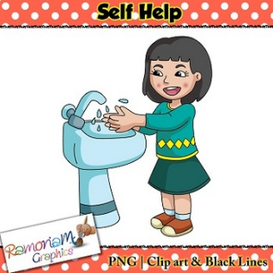

- Break tasks into small steps
Teach one part at a time. For instance, for dressing: start with pulling on pants, then putting arms into shirt, then zipping.
- Use visual supports & schedules
Charts or pictures showing each step help children remember. For example, hand-washing: wet → soap → scrub → rinse → dry.
- Provide proper tools / environment
Child-friendly utensils, step stools, clothes easy to manage (large buttons, Velcro), hooks at child height etc.
- Model & demonstrate
Let children watch adults do the tasks; talk through what you’re doing. “Watch me zip my jacket.”
- Encourage & praise efforts
Focus on the process, not perfection. Celebrate small wins, even if it’s messy or imperfect. Builds confidence.
- Make it fun
Turn self-help tasks into games or songs. For example: “Let’s see how fast we can zip before the timer goes off!” Use playful language.
- Be consistent & patient
Routines help. Repetition over time. Allow enough time; avoid rushing. Praise even partial successes.
- Gradually reduce help (scaffold)
Initially assist more; then step back, letting the child do more with encouragement. Over time, child should need less help.

Breast Feeding Policy
Breastfeeding is the normal way to feed a baby, providing many health benefits to both infant and mother. Because breastfeeding employees/breastfeeding parents need ongoing support from child care providers to provide their milk for their babies, Belmont Community Daycare Center subscribes to the following policy.

1. Breastfeeding mothers shall be provided a place to breastfeed or express their milk. Breastfeeding mothers, including employees, shall be provided a private and sanitary place other than a bathroom, to breastfeed their babies or express milk. This area provides an electrical outlet, comfortable chair, table or stand and nearby access to running water.
2. A refrigerator will be made available for storage of expressed breast milk. Breastfeeding mothers and employees may store their expressed breast milk in the child care’s refrigerator. Mothers should provide their own containers, clearly labeled with name and date. The child care will follow guidelines from the American Academy of Pediatrics and Centers for Disease Control and Prevention in ensuring that breast milk is properly treated to avoid waste. Universal precautions are not required in handling human milk.
3. Sensitivity will be shown to breastfeeding mothers and their babies. The child care is committed to providing ongoing support to breastfeeding mothers, including providing an opportunity to breastfeed their baby at any time, and holding off giving a bottle, if possible, when mom is due to arrive. Artificial baby milks (formula) and solid foods will not be provided unless the mother has requested. Babies will be held closely when feeding and bottles will never be propped.
4. Staff shall be trained in handling human milk. All child care staff will be trained every 3 years in the proper storage and handling of human milk, as well as ways to support breastfeeding mothers.
5. Breastfeeding employees shall be provided flexible breaks to accommodate breastfeeding or milk expression. Breastfeeding employees shall be provided a flexible schedule for breastfeeding or pumping to provide breast milk for their children. The time allowed would not exceed the normal time allowed for lunch and breaks. For time above and beyond normal lunch and breaks, sick/annual leave must be used, or the employee can come in a little earlier or leave a little late to make up the time.
6. Breastfeeding promotion information will be displayed. The child care will provide information on breastfeeding, including the names of area resources should questions or problems arise. In addition, positive promotion of breastfeeding will be on display in the facility. There are no advertisements of formula in the facility.

Https://cacfpny.adobeconnect.com/make_mine_bff_centers/

Trauma Smart Initiative

- Participants will become familiar with the Trauma Smart Framework.
- Participants will become familiar with the definition of trauma impacts a child’s ability to learn.
- Participants will be able to identify the parts of the brain included in the trauma response.
- Participants will be able to identify situations that trigger emotional responses for them in the classroom.

- The four blocks on the bottom represents concepts that must be in place before children can form healthy attachments.
- The three middle blocks represent concepts that are crucial for caregivers to teach and foster self -regulation skills in young children.
- The top three blocks represent concepts that are critical for identity formation, critical thinking, and trauma integration.

How Trauma Effects Children:
- Tantrums
- Withdrawn / Fearful
- Inability to get along with others
- Separation Anxiety
- School Phobia
- Eating Problems
- Stomachaches

Impacts

- Adult domestic Violence
- Depression
- Early Onset Sexuality and Sexual Promiscuity
- Teen Pregnancy and Paternity
- Suicidality

Our Brain as a car 

Meaning ----- Pre-frontal Lobe --- Thinking State ---- Front Seat
(Thinking Planning, Evaluating)

Connection -----Limbic System --- Emotional State ----Back Seat
(Emptions and memory)

Safety --- Brain Stem -----Physical State ------- Trunk
(Fight, Flight, freeze, Faint Response)

What is Meditation?
The English term meditation is derived from the Latin term meditatio, from a verb meditari, meaning "to think, contemplate, devise, ponder.” Meditation is a mind-body practice through practicing techniques such as focused attention, a specific body posture, and no attention/openness to distractions. Mediation can be practiced while standing, sitting, or in an active way such as yoga.


Health Benefits of Meditation:
- Relieves stress
- Treats insomnia
- Aids weight loss
- Boosts memory
- Reduces blood pressure
- Improves focus
- Promotes emotional health
- Enhances self-awareness
- Generates kindness 😊

“What you think, you become. What you feel, you attract. What you imagine, you create.”
~ Buddha

Meditation Station

- Zenful Environment
- Relaxation and Meditation
- 10 Minute Experience
- Meditation is to find inner Peace
(1-2 persons per experience)
18 or older

“Meditation can be defined as a practice where an individual focuses their mind on a particular object, thought or activity to achieve a mentally clear and emotionally calm state. Meditation may be used to reduce stress, anxiety, depression, and pain. It may be done while sitting, repeating a mantra, and closing the eyes in a quiet environment.”



Namaste
Meditation Station
Options
“Find your Zen!”
- Sunglasses
- Mirrors
- Essential Oils
- Playdough
- Coloring Books
- Marble Maze Sensory Bag
- Feelings Books
- Sand Timers
- Feathers
- Sensory Balls
- Weighted Puppets
- Sensory Snake
- Smart Beads
- Fidget Spinners Finger Puppets
- Feelings Chart
- “Make your own Face!”
- Bead Patterns

Trauma Smart

Belmont Community Day Care Center participated in Thrive NYC Trauma Smart. As a Year 2 Trauma Smart selected site, you are now a part of a movement to ensure that all caregivers are informed in Trauma Smart best practices that strengthen healthy behaviors and support emotional growth in children.

Since September 2017, Belmont has completed all ten modules of Trauma Smart, received invites to conferences and further learning opportunities, participated in our Academies which aid in Trauma Smart sustainability, and coaching from our team of Social Workers. We hope that your involvement in this program has widened your view on trauma informed care and allowed for moments to create a trauma informed agency.

http://traumasmart.org/partner-portal/login In January 2019, we will be releasing our Workshop Request Booklet which will allow your center to submit specific requests to the Trauma Smart Team.


Library
In 2005, a large library was designed to encourage a respect for the written language and a love of reading. The Belmont Library is decorated with comfortable furniture and colorful bookshelves. Famous artist and authors adorn the walls, including Leonardo Da Vinci, Vincent Van Gogh, and Dr. Seuss. The equipment and materials in the room are comprised of a listening center, interactive story puppets, magazines, and a comprehensive collection of over 10,000 books covering all our thematic units as well as an assortment of books for enjoyment. These books allow the children to broaden their horizons by journeying through a world of new information. The books deal with an assortment of subjects and authors, offering the children a wide selection of lending library books. The children have scheduled Library time where they have the opportunity to choose a book to take home for the week. Our program promotes picture reading, small group time reading, individual reading, puppetry, interactive storytelling and read aloud dramatization.
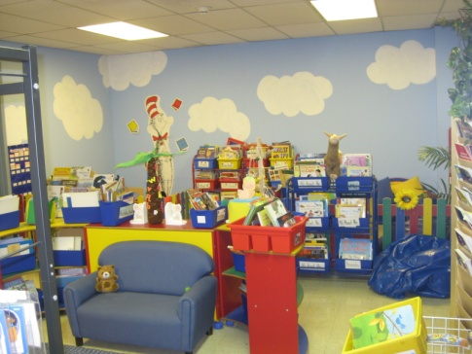

Literacy Program Creative Arts Team

Beginning in 2009 we had the pleasure of collaborating with CAT/NYC Wolf Trap program: Early Learning through the Arts. Ms. Helen Wheelock is our consultant, and she trains many of our teachers and supplies workshops for our children.
The Belmont Community Day Care Center has had the pleasure of working with the literacy creative arts team. This program has supplied our program with a literacy coach for three of our Pre-school classrooms and teachers. Ms. Helen spent an hour one day a week in our classrooms telling dramatized stories that entertained the children and taught our teachers new skills in dramatization and storytelling. The class’s lasted for two months and enriched our curriculum. Ms. Helen spent one hour a week, providing the teachers with staff development. The experience was enriching for both our children and staff. We look forward to working with the creative arts team next year.

Studio in a School

The Belmont Community Day Care center has been in collaboration with Studio in a School since 2008. Our Program received a grant, which allowed for four of our pre-school classrooms to work with an artist once a week. An artist covers an extensive art curriculum that includes collage art, construction, paint, clay cycle and puppetry. Studio in a School designed their curriculum to allow the children to explore various art materials and develop with them. Some of our children’s work has been displayed in Studio in a School’s gallery. We look forward to continuing our relationship with Studio in a School.

Block Room
In 2008 our program developed a separate Block Room for the children to visit on a monthly basis. The children have the option to revisit their work the next day, for an extension of their thoughts and creativity. Pictures of our community’s buildings, stores, and homes decorate the room.

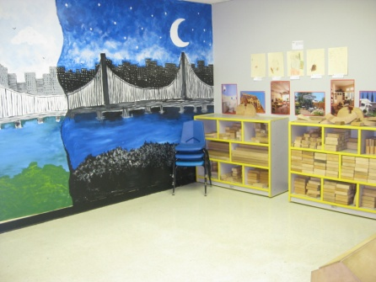
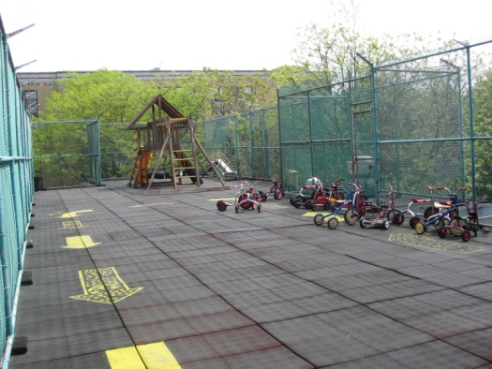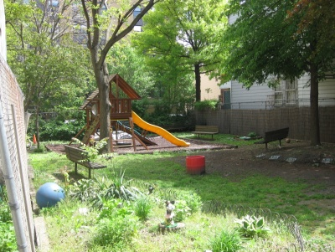
Big Room Indoor Recreational Area and Outdoor Recreational Areas
These large play areas have an assortment of materials for physical activities and games. The teachers prepare activities on a daily basis. Our staff is trained in the Sparks program that is sponsored by the Department of Health. The children receive more than two hours a day of music and movement. Physical activity is important to the developmental growth of each individual child.

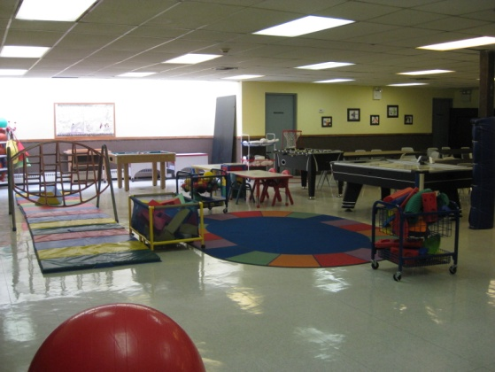

Educational Workshops, Consultants and Trips
Our program has worked for the past five years with distinguished educational foundations such as the Maritime Aquarium, Central Park Zoo Wildlife Theater, the Bronx Zoo, Botanical garden’s, Liberty Science Museum, New York Aquarium, Scholastic Book Club and Quiver Farm Projects. These foundations have enriched our program and entertained our children with interactive activities,
hands-on experiences and musical performances.
Local Engine #88 provides onsite inspections to ensure the safety of our children and they also enhance the children’s interest by allowing us to visit and experience the firehouse firsthand. Our program arranges three trips to the Botanical Gardens, allowing the children to see the change of season while exploring the great outdoors. Our community merchants have opened their doors to our children in order for them to discover how the baker makes fresh bread, where the mail goes after the mailboxes and why a police officer is important for our safety.
Our Board of Directors has been most gracious and supportive in funding our yearly Broadway trip. The children have had the opportunity to be an audience to such shows as the Christmas Spectacular, Anne and The Little Mermaid. This opportunity is not only educational, but a magical experience that we hope the children continue in the future.
Our program has visited the Children’s Museum, New York Aquarium, Central park Zoo, Build a Bear Workshop. Our trips reflect our thematic units that are being experienced in the classroom. We look forward to finding new fundamental environments that we can share with our children.
Wildlife Conservation Bronx Zoo/ Central Park Zoo

The Bronx Zoo and Central Park Zoo share all sorts of animals through theatrical shows teaching our children about migration, hibernation, and the characteristics of all types of animals.

Quiver Farm

Quiver Farm offers our children an assortment of educational programs that introduce Farm life to our city kids. Quiver farm brings the farm experience to our site. Our children have learned how to milk a cow, turn butter, press olive oil and raise baby chicks all in their backyard.

Maritime Aquarium

The Maritime Aquarium brings sea life to our center through interactive storytelling , developmentally appropriate activities and hands on experience with sea creatures.

Belmont Library and Enrico Fermi Cultural Center

The Belmont library allows for easy access to an assortment of books, DVD’s and computer resources.

St. Barnabas Hospital

Workshops, trainings, family information and resources for health & mental health services.

Lehman College / Jump Start
Belmont Community Day Care collaborates with Lehman College in order to strengthen the educational professional field. Working together children and student educators are learning from one another. Experience is worth everything!

Sparks/ Move to improve
Move-To-Improve

Move-to-Improve is a classroom based curriculum designed by the New York City Department of Education (DOE) and the New York City Department of Health and Mental Hygiene (DOHMH) to increase physical activity among students, Pre-K-5, in elementary school.
Move-to-Improve helps elementary school teachers incorporate short structured fitness breaks into their classrooms. These fitness breaks integrate grade-level academic concepts and physical activity in a 10-minute educational lesson and are aligned to New York State Physical Education Learning Standards. Move-to-Improve can supplement a school's existing physical education program and help schools meet the New York State Education Department mandate of 120 minutes of physical education per week.
Botanical Gardens
New York Botanical Gardens is a beautiful wonderland that enables are children to research flowers, stretch their legs, and attend child educational workshops such as chocolate and vanilla, edible foods and the train show.

Local Merchants
Merchants in the Arthur Avenue community foster the children’s learning through hands on experiences that enable them to explore the worlds around them. (Arthur Avenue Bakery, Artuso Pastry, Borgoti’s, Egidio’s Arthur Avenue Market, Raddazo’s fish store, Joes Deli, etc…

Engine 88
Engine 88 is our local Fire House that opens and invites our children into their house. The children have the opportunity to climb up on the truck, spray a water can, dress like a fire fighter and ask as many questions they can think of.

Eat Well Play Hard Program (Champion Program)
The Belmont has become part of the Eat Well Play Hard Program that is sponsored by the Department of Health. The program includes teacher, child, and parent workshops. The program comes with a curriculum and they supply our site with materials needed. The activities are healthy and developmentally appropriate for early childhood. Each week our teachers prepare the materials in our down stairs kitchen for a small group of children to participate. The children have made salads, soups, dips, fruit shakes, etc. The curriculum also includes physical fitness activities to get those large muscles moving. The program supplies the children with a great learning experience and it motivates them to eat healthy and exercise daily.

Future Chef:
We would like to welcome your child to our “Future Chef’s” cooking club. In order to make this a successful program, we need to know if your child has any food allergies that can be hazardous to his/her health. Some allergies may include lactose intolerance (milk), nut allergy (peanut butter, almonds, walnuts, eggs, chocolate, etc.) Please make us aware if your child has any of these allergies, or any other allergies.

Cornell University

Cornell University has supplied our families and children with detailed nutritional classes and physical fitness opportunities. The children, staff and family have participated in stimulating, yummy cooking experiences. This program supplies families with many nutritional affordable meals.

The Child of the Week


“The Child of the Week”. This is how we get our “Show and Tell” in. Your child becomes the V.I.P. for the week. Every child participates with the help of a parent. We believe that each child is unique! In this project, we would like to see your child’s interest, talents, and experiences shine. All children will learn from each other. Parent involvement is essential! A schedule with names will be provided. It is important that you mark your calendar so that you know when it’s your child’s turn. You must decide with your child, items he/she would like to display.
Some ideas ………..

- Favorite books/stories
- Drawings/ Paintings
- Creative stories
- Favorite toys/games
- Hobbies
- A photo poster board displaying people in your family, or places you visited.
- Pets
Please keep in mind, the things that you send in must be special to your child. We will display your child’s collection in a special area in our classroom. It will be viewed by everyone who visits our classroom. We appreciate your help. If you have any questions, feel free to ask. We would like you to keep this information at hand so that you can refer to it when it is your child’s turn. Please understand that you will get all of your child’s things back at the end of the week

Bilingual Birdies

Aside from what will be the most fun part of your week, there are countless important benefits your children will gain by participating in our program! Here are just a few reasons to tap yourself on the shoulder for being such a stellar parent and bringing your children to Bilingual Birdies each week.
ADVANCED COGNITIVE DEVELOPMENT
SOCIAL & EMOTIONAL ADVANTAGES OF BILINGUAL BIRDIES METHODOLOGIES
INCREASED OPPORTUNITIES IN A GLOBAL SOCIETY & JOB MARKET
MORE OPEN-MINDED


nyc.bilingualbirdies.com/nyc

Daddy and Me
The daddy and Me Program was created in 2011 to get fathers more involved in their children’s educational careers. Throughout the year the Daddy and Me committee but together a number of activities that are fun, educational and meaningful to the families we services. Activities such as ornament making, cooking activities, basketball games and read along are just a few of the activities that our dads are able to participate in with their children.

“Dads Take Your Child to School”
Dads Take Your Child to School is an annual event held throughout New York State celebrating the special relationship that fathers have with their children. The event occurs at the beginning of the school year: inviting fathers, foster fathers, grandfathers, uncle, brothers, godfathers, and other significant male caregivers to accompany their children to school on a specific day and encourage them to make a commitment to participate in their child’s education throughout the year.

Fathers have an undeniable effect on their children. Studies show that positive paternal involvement is associated with improvements in children’s:
- Academic performance
- Cognitive development
- Behavior
- Psychosocial development
- Health and wellbeing
- Household economics, and
- General/overall parenting quality

Month of the Young Child

The Belmont has been celebrating Month of the young Child each May. The Month of the young child is our way of recognizing all the hard work that goes into educating our young children throughout the year. Early childhood education is the development of a child’s foundation for their educational future.
The Belmont program celebrates all the domains of early childhood learning, through fun and creative activities for the whole family.
Such activities as face painting, balloon animals, arts and crafts, a dunk tank, bouncy house, music, BBQ foods, and raffles are all a part of the day’s fun.
Come and join the activities this year with your family. We love to see alumni!!

Trips
Trips are an integral part of the program learning for all children. Since children learn best from first hand experiences, trips afford them an opportunity to expand their knowledge and understanding of the wider world, as well as perceive all the wonders of their everyday life. Trips, in and of themselves, are not the total learning experiences. Preparation for the trip adds to experiences and opportunities to relive and act out the trip later in the classroom activities enriches the child’s total being. Trips are an extension of the curriculum and learning process for the development of the individual child. Parents who wish to accompany Belmont on trips must attend one of the mandated Trip committee meetings at the beginning of the school year. At these meetings administration and Staff will review the safety procedures and policy regarding trips.
Trip Etiquette
Parents are asked to accompany our staff on trips which helps and guides the children’s exploration. We ask that the parents supervise a small group of children besides their own. We ask that the parent follows the directions from the trip coordinator. Lunch will be supplied for the parent if they wish. Parent volunteers are greatly appreciated and with their help, all the children have the ability to safely explore their surroundings.
Parent Helper Trip Policy
Thank you so much for your interest and willingness to be a parent helper in your child’s classroom. Your time and dedication to your child and the classroom supports our goal to create a rich experience for all.
The definition of a Parent Helper is as follows:
A parent helper is defined as a person who aids in his/her own child’s classroom. Parent Helpers must remain in the classroom and be accompanied by a teacher at all times. Parent Helpers must be within eye or ear shot of a staff member at all times.

Field trips at Belmont Community Daycare Center are taken for many reasons. We are trying to enrich and extend classroom learning while helping children to enjoy a safe and happy experience outside the classroom. It gives children an opportunity to increase their feeling of competence as they journey into new adventures. As children learn they are able to try new experiences outside the family structure, they can gain a feeling of independence and confidence which in turn increases self-esteem.
In order to achieve all this, we will need help from parents on field trips. The teachers and parents at Belmont Community Daycare Center believe that field trips will be safer and more beneficial if all parents who attend field trips understand what their role on the field trip is and how they can most help the teacher and the children. Because we know that like us, you want what is best, several parents and teachers have worked together to develop guidelines that we believe will make the field trip experience a good one for all the participants. On certain field trips, for many reasons including safety, space, and the above stated goals, the teachers and administration will limit the number of parents that will be able to go on a field trip. Please respect the limit that is set by the teachers and administration. We will do our best to see that parents are allowed to go on at least one field trip or be involved in special class activity once during the year. We want you to be involved and we will continue to try to offer many opportunities for parent involvement. Please
understand that in order to allow all parents to have a chance to participate and to give your child a chance to achieve the feeling of independence, increased confidence, and self-esteem, you will probably be limited in the number of field trips in which you can participate.

The complete list of requirements for a Parent Volunteer is as follows:
- Please sign in at the front desk before going to your child’s classroom
- Wear your parent helper badge at all times
- Remain within eye and ear view of staff member at all times
- Arrive 10 to 15 minutes earlier so the teacher can let you know exactly what your responsibilities are during the trip.
- In order to give your full attention to the children you are supervising:
- It is imperative that you do not bring siblings on a field trip.
- Please do not bring a cell phone. In the case of an emergency, one teacher will have a cell phone where you can be contacted. Please leave the school number 718-584-1576 for an emergency and we will then be able to contact you on a trip.
- Please do not bring a camera. The classroom teacher will have one and can share the picture with you.
- Purchasing food, drinks or a souvenir for yourself or your child is prohibited.
- No smoking.

I _______________________________________ agree to follow the above set rules.

Parent Signature: _________________________________ Date_______________

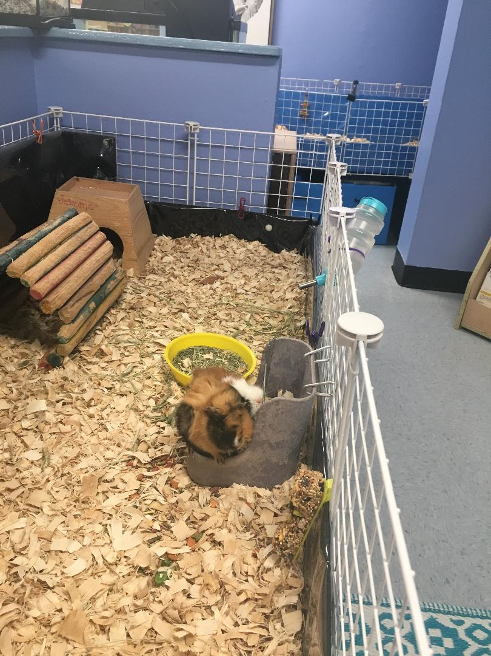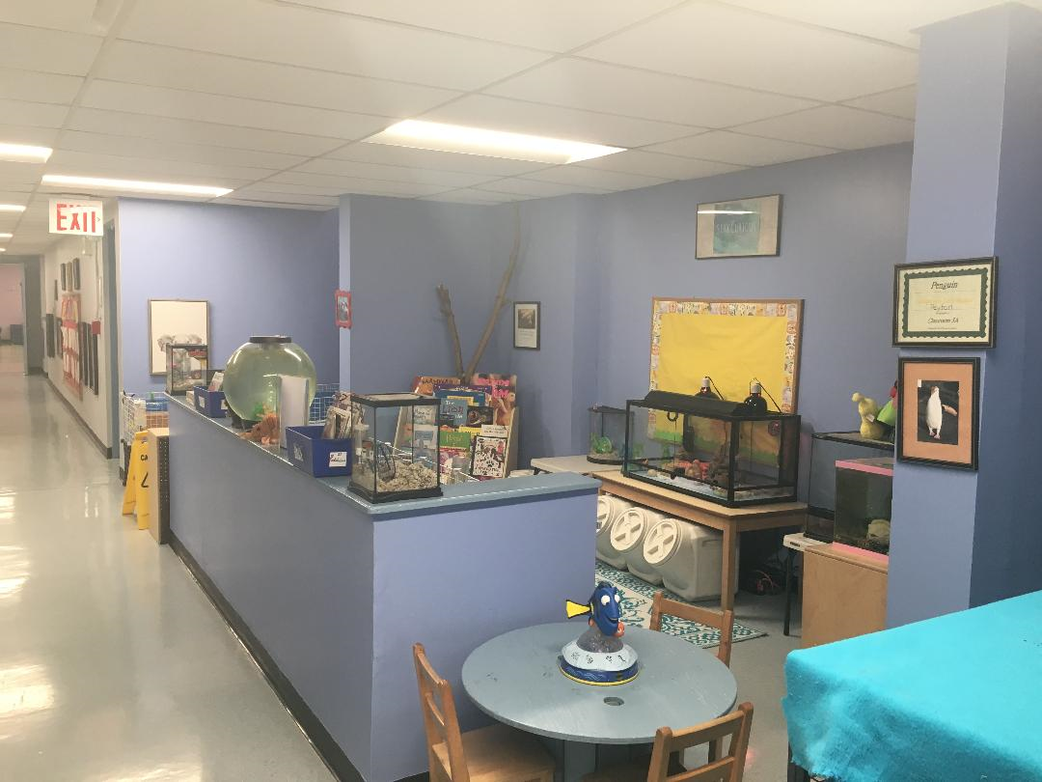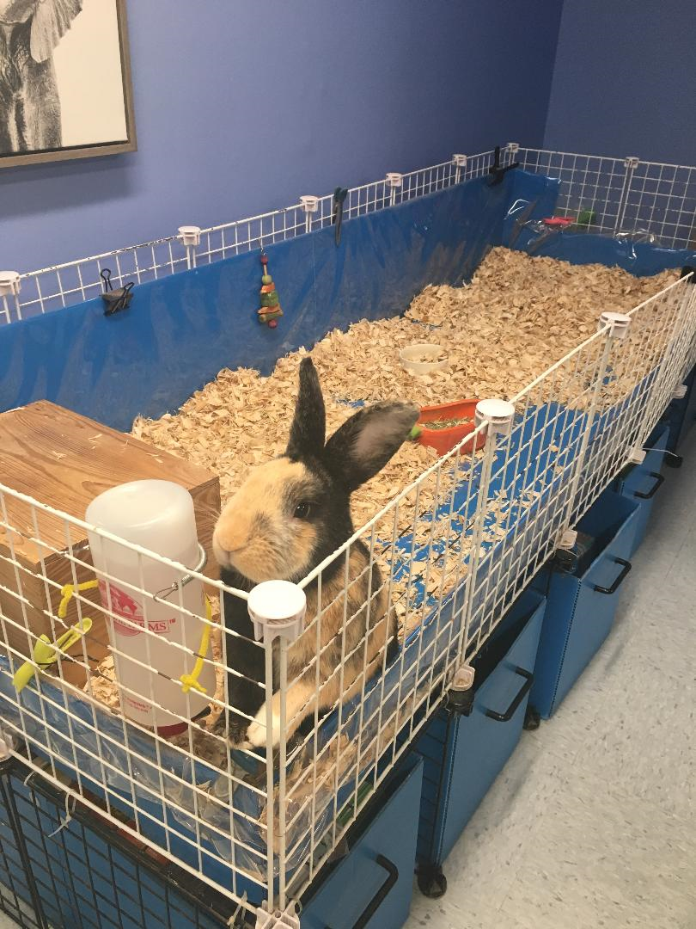

Animals in the Classroom

Animals play an important role for many, many reasons. Children are small in the world and have little power of their own. Caring for an animal provides the experience of taking care of a living being even smaller and more vulnerable than they are.

Animal well being

Animals have certain needs in terms of natural light, heat, privacy and so on. To meet these needs and ensure that an animal feels as comfortable as possible, establish an area of the room specifically for the pet. Consider the placement of the animal’s enclosure and how the children will engage with it. An adult must be able to easily view the children’s interactions with both the animal and the enclosure.

Young Children – Clarissa Uttley Animal Attraction: Including Animals in Early Childhood Classrooms pages 16- 25

Benefits of Classroom Animals
Classroom Pets Stimulate Learning Classroom animals are wonderful resources for teachers to make learning fun in all subjects!

Pets Bring so Many New Ways to Learn
Whether it’s Math (“how much does a hamster weigh?”) or Science, (“what does a bird eat?”) Geography (“what part of the world do Guinea Pigs come from?”) or Grammar (“what words would we use to describe a goldfish?”) students will approach learning all these subjects with a new enthusiasm and interest. Other classes can even come visit your classroom pets and your students can create special presentations about the animals.

Pets Enrich the Classroom Experience
• Even kids with no exposure to animals or nature in their home environment can see, feel, touch and make connections to the wide world of animals.
• Observing and caring for an animal instills a sense of responsibility and respect for life.
• A pet brings increased sensitivity and awareness of the feelings and needs of others—both animals and humans.
• Kids learn that all living things need more than just food and water for survival.
• Students will see directly how their behavior and actions affect others.
• Studies show that the presence of animals tends to lessen tension in the classroom.

A Child’s Health, Education and Welfare
Caring for pets in the classroom is one way of improving school attendance and teaching children about responsibility.

Welfare
The study also showed that kids turn to their pets for emotional well-being, with 40% of children choosing pet companionship when feeling down. Kids were also found to seek out their pets when feeling tired, upset, scared or lonely, and 53% of respondents said they enjoy doing homework with pets nearby. “Being around animals is extremely good for children”, says Dr. Harvey Markovitch, pediatrician and editor of The Archives of Disease in Childhood. “They’re good for morale, and teach children about relationships and about the needs of another living being – learning to care for a pet helps them to learn how to care for people”. Studies show caring for pets aids in improving school attendance and teaching children about responsibility.discoveryhealth.com
Studies show caring for pet’s aids in improving school attendance and teaching children about responsibility.

Pets Encourage Nurturing
Nobody enjoys being treated roughly. Kids soon learn that if they want to be liked and trusted by the family cat, they’ll need to treat her carefully and kindly. This sort of training benefits all kids, but is especially important to small boys who don’t often get the chance in our society to practice nurturing skills as girls do.

Pets Build Self Esteem
Helping to take care of a pet gives a child a sense of pride and accomplishment, especially if the animal is able to return the affection. Shari Young Kuchenbecker, Ph.D., research psychologist at Loyola Marymount University in Los Angeles, says, “The child who cares for a pet knows that what he does matters, and so he’ll want to do more of it. The more successfully he feeds, walks, or emotionally bonds with the pet, the more confident he’ll feel.” In fact, studies conducted by the Waltham Centre have shown that children with pets have higher levels of self-esteem than those without pets.

Pets Teach Responsibility
Even a small child can begin to learn to care for the needs of another living being. Whether helping to empty a cup of dry kibble into the rabbit’s bowl, or filling the hamster’s water bottle, it’s never too early to start teaching kids proper animal care. Of course, parents or teachers must monitor all pet care that the child carries out. Kids should be expected to fulfill their responsibilities, but when the inevitable slip-ups occur, we shouldn’t make too much of a fuss; we should just point out that the pet was counting on him.

Pets Become Friends
Lots of animals such as cats, dogs and guinea pigs love human contact and can become a child’s best buddy. Kids can even develop strong human animal bonds with non-responsive animals such as fish or turtles. These relationships help to strengthen a child’s social skills, giving them the potential to do better in a school setting. (sesameworkshop.org)
http://www.petsintheclassroom.org/teachers/benefits-of-classroom-animals/

Is your classroom ready to provide total pet care 100% of the time?
Educators have successfully kept animals in the classroom for decades. From an aquarium full of goldfish to the hamster who roams the classroom floor in his roller ball, there is no doubt that critters are a great educational tool. But there is more to keeping a classroom animal than just buying a cage and a bag or two of food. A classroom pet depends on you for its health, happiness and well-being. Is your classroom ready for the responsibility? And what sort of animal is the right one for your needs?
Here are some things to think about before choosing a classroom pet:
- Animals need food, water and a clean, safe environment. Most of all, they need regular attention and nurturing. You must be prepared to provide for their needs on an ongoing basis.
- A pet needs to feel safe and protected from chaotic surroundings. You must make sure your animal has a safe place to hide when it feels overwhelmed by attention or classroom noise.
- For health and safety, you must stick to the animal’s regular diet. Absolutely no bits of sandwich or candy can ever be permitted.
- Some animals need to roam outside their cage periodically in order to stay healthy and happy. Can you provide a safe and secure setting for this?
- How will pets be cared for on weekends and holidays? If the pet goes home with a student, a parent MUST be held responsible for the animal’s care.
- If the pet becomes ill, are you prepared to care for it? You should keep a vet’s phone number handy in case of emergency
- Oops, it turns out you’ve got a boy and girl hamster/rabbit/goldfish. Are you prepared to accommodate babies? Will you spay or neuter your larger pets?
- Are allergies a problem for your students? Be sure to take this into account when choosing the type of animal to bring into the classroom.
Whether it’s a rabbit or parakeet, a goldfish or a turtle, the right pet will reward you and your students with a world of companionship and learning opportunities
http://www.petsintheclassroom.org/teachers/is-your-class-ready-for-a-pet-in-the-classroom/

Program Assessment

Self -Assessment

In early 2006, the city of New York Administration for Children’s Services (ACS) and Department of Education (DOE), with support from the child care and early education fund, jointly commissioned a team of consultants to create a uniform and comprehensive performance measurement system for publicly-funded early care and education programs, including center, school and home base care in the city of New York.

The following rating scales are utilized to insure quality throughout the program:
- ECERS-R – Third Edition--- Early Childhood Environment Rating Scale
- CLASS---- Classroom Assessment Scoring System--- Manual Pre-K

The Self – Assessment team works throughout the year to document the necessary growth and development of the program. The committee meets monthly to collect and analyze necessary data, collect and organize necessary documentation and assist the overall development of the program. The committee is made up of board members, administration, educational staff, support staff, parents and Alumni. In conclusion of the self-assessment—school readiness goals are created to support the educational and programmatic dynamics of the following fiscal year.

ECERS Early Childhood Environment Rating Scale

The Belmont Program has begun studying and attending workshops on the early childhood rating scale. Our Board of Directors has familiarized them with the tool and has begun making the appropriate changes for our future development. The high quality standards have been outlined and posted in our many learning areas. Our Board of Directors has hired early childhood educators to administer the tool, to guarantee a proper assessment. Our goal is to provide our community with a quality early childhood program. A parent survey and questioner are given out several times, to promote family involvement and improvement of our programs. Here at the Belmont we are constantly in search of ways to offer new and valuable services to our families and always we are searching for additions that will inspire our teaching staff so they can inspire all our young minds.

CLASS

The Classroom Assessment Scoring System (CLASS) is an observation instrument developed to assess classroom quality in preschool through third-grade classrooms. This preschool manual provides information on the theoretical and empirical foundations of the CLAS, an overview of the procedures for using CLASS, and detailed descriptions and examples for each dimension as observed in preschool classrooms.

NAEYC (National Association Early Childhood)
The Belmont has researched accreditation with the National Association for Early childhood. We have been preparing our facility and staff to begin the process. We are planning to enroll and begin our journey by the 2022-2023 school years.

Pre-School and After School Fact Sheet
- Children should not be left at the day care center before official opening hours.
- Pre-School Children will not be accepted later then 9:00 am unless it is an emergency and the center is informed.
- Children must be escorted into the classroom by parents or authorized escort and signed in.
- Please check your child’s cubby each day.
- If a child arrives or departs from the center with an escort who threatens the health, safety and welfare of the child, the director will notify the parent and recommend that the parent designate a more appropriate escort.
- No child will be permitted to go home un-escorted and Permission over the phone is not acceptable.
- Authorized responsible escort must be at least thirteen (18) years of age. Escort must be designated by the parent in the writing on their white or blue card. Day care staff will not release a child to any individual who has not been designated by the parent.
- Parents are allowed to observe their child at the center at any time. Please make arrangements with
the Director before doing so.
- Hours of services are arranged by the director based on individual need. It is absolutely necessary parents abide by the hours of service agreed upon during the initial in-take meeting. Hours of service may be re-arranged providing an official letter from employer or school stating hours of work or school attendance.
- Failure to pick your child up after 5 pm will result in a$1 a minute fee.
- Continued failure to pick up your child at the agreed time will result in a termination of the services.
- Parents are responsible for providing the center with two emergency contact people, in case of an emergency.
- Menus are posted outside the Directors door , classroom door, and sent through Remind App.
- Recertification appointments and paper work must be taken care of in order for the child to continue their services with the Belmont Day Care.
- Children who are attending an early childcare setting for the first time are slowly transitioned into the program, schedule and routine. Parents are asked to bring the child in at 9 am and pick the child up at 12:30 pm for the first three to five days depending on the individual needs of the child. Parents are more than welcome to stay during this period.
- Parents are encouraged to schedule an appointment with the teacher or Director to discuss the child’s progress.
- Each child is required to have two (2) clean sheets at all times. Dirty sheets are to go home on Fridays and clean sheets to return on Monday’s.
- An appropriate change of clothing must be left in the child’s cubby at all times. Please change the clothing each season.
- Day care employees are prohibited from administering any medication to your child.
- Fees are due on Mondays and Tuesday. (Money Order or Cash) Checks are not accepted.
- Brining in personal items such as books, toys, jewelry is discouraged. The center will not be responsible for their loss or damage.
- Children are to be dressed appropriately for comfort, weather and play.
- No food, drinks or medication of any kind is allowed to remain in the children’s cubbies.
- All parents need to sign their children in and out of the Belmont Community Day Center on a daily basis. Sign in requires a legal signature.
- Children are not allowed in the building without an up to date Department of Health Medical.
- Parents are required to participate in Day Care Activities, Parent workshops, parent/ teacher conferences, class trips, and any other functions that involve the development of your children.
- Children are to be picked up from the following places, classroom, big room recreational area, courtyard, garden or roof recreational area.

- The last pick up time is 4:45 and a 15 min. grace period is supplied until 5:00 pm. Every minute the child remains in the building after 5:00 p.m. will cost 1 dollar per minute.
- Attendance is mandatory and if for some reason your child cannot attend school please
call 718-584-1576 early in the morning and notify the front desk.
- Please notify the administration if your child has been diagnosed with a contagious disease.

Parent Agreement:
I understand that my participation in my child’s developmental growth and education will help my child’s developmental progress and growth:
- Encourage my child’s social development through conversation and interaction on a daily basis.
- Encourage my child to be respectful and peaceful member of the Belmont Program
- Participate in teacher conferences, class programs, and other activities in which my child is involved.
- Assure that my child will arrive at Belmont on time every day.
- Spend at least 15 minutes per day reading with my child
- Listen to the retelling of his/her school day experience
- Provide the day care with current telephone numbers and emergency contact information.
- Alert the Day Care if there are any significant changes in child’s health or well-being that affects his/her ability to perform in our program.
- Assure that you have supplied the day care with the appropriate up to date paper work. (Medical, recertification paper work, evaluation signatures)
- Assure that I have signed my child in and out of the day care on a daily basis. Properly signing my full legal name.
- Supporting my child’s exploration and discovery through play.
- Family style eating at home.
- Participating in workshops, trainings and events
- Supervised T. V. Time
- Participation in Family activities
I have read the Belmont Parent Handbook and I am aware of my responsibilities as a parent participating in the Belmont family and community. The following policies and procedures have been implemented for the safety and comfort of my child(ren) as well as the 180 families the Belmont services each year.
I ________________________________ have read the parent handbook and will cooperate with all policies and procedures that are outlined here.

